

Reporting Template
Contingency Fund for Emergencies (CFE)

Financial and technical reporting on funds allocated through the Contingency Fund for Emergencies (CFE) is essential. Together with other visibility items – such as high-quality photos with captions and human interest stories – reporting is a key element of the CFE fundraising strategy, as it helps us strengthen our case with donors and remain accountable to them.

This short document is intended to guide you as you produce the final technical (narrative) report for the CFE award received by your office. Part 1 explains why and how we write a CFE report. Part 2 includes a template with examples. Part 3 contains a check-list to ensure nothing is missing. Please read all three parts before drafting your report. Examples of past CFE reports can be found on the CFE Sharepoint folder.

To draft your report:
- Use the template included in Part 2
- Replace the examples with relevant content on the CFE award received by your office
- Go through the check-list in Part 3
- Delete all the explanatory parts of the document (i.e. page 1, Part 1 and Part 3)
- Rename the Word file as CFE technical report-year-CO name-Emergency type- Award number
> Example: CFE technical report-2022-South Sudan-72988

A CFE technical report should be submitted within eight weeks of the award end date to the Contingency Fund Manager at HQ: contingency-fund@who.int. In case of multiple allocations for the same event, a final consolidated report should be submitted within eight weeks of the end date of the last award. For more information on CFE financial reporting, see the WHO eManual XVII.6.1 Contingency Fund for Emergencies (CFE) under the section “CFE Allocation, Closure and Reporting” (points 210-240).

- INTRODUCTION

Why write a CFE report?
The CFE is financed through flexible voluntary contributions. Disbursed funds must be replenished to ensure that the CFE mechanism continues to be available for future emergencies.

Accurate and timely information about why CFE funds were needed, how they were used, and who benefited from their use will enable WHO to continue to replenish and expand the CFE. This will ensure that the Organization maintains its ability to act quickly in the face of future outbreaks and health emergencies. Impact reporting provides convincing evidence to donors of the CFE’s effectiveness, encouraging them to continue to invest in the Fund. The information and stories contained in these reports are also used in other advocacy products throughout the year (e.g. social media and web stories), and in the CFE annual report. WHO is also required to submit financial, implementation and performance data on the CFE to the Organization’s governing bodies.

A CFE technical report should contain all the narrative detail and quantitative data on the implementation and performance of CFE-funded activities.

How to write a CFE report?
It is important to note that a CFE report will not be sent directly to donors. However, it must contain enough narrative detail, human interest, and relevant quantitative data to enable the production of detailed information products that can be used both to justify past CFE awards to current and prospective donors and to ensure WHO can account for CFE expenditure to its governing bodies.

Using the template below (Part 2) will help you achieve the overarching purpose of the report, which is to draw clear links between:

- WHY the funds were needed
- Contextualize the emergency, preferably by adding maps of the affected areas.
- Discuss what was required to respond to the emergency (e.g. activities and equipment).

- WHAT the funds accomplished
- Focus on outcomes. Rather than just mentioning actions, focus on their impact.
- Include illustrations (charts, maps, photos, and tables). For maps and charts include title and source; for charts, please also attach the underlying data.

- WHO the funds benefited
- The ultimate aim of WHO’s emergency work is to relieve the suffering of people affected by crises. If possible, include a human interest story centred on a project beneficiary, and describe how the project has helped improve his/her life (see the WHO Storytelling Emergency Kit)^{i}. You can share the story’s web link in the “Visibility” section of the report (see below) or paste story at the end of the report as an annex.

Following just a few simple rules will make writing and reading the report as easy as possible:
- Write clearly and concisely
- Spell out abbreviations and keep their use to an absolute minimum
- Assume the reader is a non-specialist, so always explain technical terms and concepts
- Write in a simple and clear way, and avoid UN jargon
- Use the template in Part 2 to help structure your report

^{i} Email contingency-fund@who.int to request a copy if you didn’t receive it with your CFE request pack and can’t access the CFE Sharepoint folder.
- TEMPLATE

- Project summary
- Introduction
- Main achievements
- Enabling the project: implementing partners
- Operational challenges
- PRSEAH
- Conclusions and way forward
- Visibility

I. Project summary
Project title
Project location | > Example:8 drought affected districts of Sindh province and fourteen districts of Balochistan province.
WHO responsible
Officer
Amount of CFE allocation (there may be more than one allocation)
Date CFE funds requested
Project implementation period | > Example: 01 February - 30 June 2019  (Three months initial plus two months of no-cost-extension)
Beneficiaries | > Example 4 million people in both drought-affected provinces.
Goal | > Example To improve the health status of targeted populations in the 22 drought-affected districts in Balochistan and Sindh provinces of Pakistan.
Outcome(s) | > Example:  - Access to essential emergency healthcare improved –including maternal and child health, as well as mental health.  - Communicable diseases trends monitored in a timely manner; outbreaks investigated and responded to within 48 hours of reporting.
Follow-up support in place | > Example: Yes, through a CERF grant.

II. Introduction
This section should outline the main rationale for the CFE funding request in no more than a page (about 350 words). It might be helpful to use the original request for funding that was sent to the CFE to complete this.

- Briefly describe the nature of the emergency and the public health situation in the country at the time the project was initiated.

> Example: In mid-March 2019, heavy floods were reported in Balochistan province. The most affected areas include X, Y and Z. Approximately 4.4 million people were directly or indirectly affected – 670,000 of them children under 5 years of age and 370,000 pregnant and lactating women. Due to the heavy floods, a total of nine hospitals, 17 emergency stations, and the Emergency Operations Center (EOC) of the Medical University were damaged.

- Summarize:
  - WHO’s rationale (the “what”, “how” and “why”) for the project (as per the original project proposal).
  - If applicable, the objectives of the Strategic Response Plan to which the funds contributed.

> Example: As a highly trusted partner, WHO has been officially requested by the Ministry of Health to provide technical and logistical support to floods and outbreak surveillance. This underlines the unique standing and good reputation of WHO.

WHO developed a comprehensive response plan to reduce preventable mortality and morbidity by providing X, Y and Z. Specifically, the requested CFE funds were needed to cover the rapid procurement and supply of essential life-saving medical equipment, drugs, and disposables; fill gaps in X and Y; and maintain essential services, including mental health and psychosocial support.

- It is very important to summarize any major changes during the project that led to modifications to the original plan (e.g. shifts in activities, budget reprogramming, and additional funds received from donor).

> Example: Due to X, activities had to be partially shifted from Y to Z and funds had to be reallocated to prioritize Y and Z. Additional funds from Y and Z totalling US$ X allowed to expand activities to include X, Y and Z.

III. Main achievements
In this section, highlight the project’s main achievements (350-500 words). Achievements can include, for example, the number of:
- Beneficiaries reached during the reporting period
- Health care facilities provided with medicines and supplies
- Mobile clinics supported
- Patients treated
- Disease alerts investigated and responded to (disaggregated by type of disease). Add time of response if possible (e.g. within 48 hours)
- Health care facilities assessed for functionality
- Children vaccinated (disaggregated by age, gender and location if possible)
- Health care workers trained (broken down by topic and type of health worker trained)

> Example: Thanks to the CFE allocation, WHO Pakistan ensured that affected populations had access to essential and life-saving medical supplies and services. During the reporting period, a total of 282,000 beneficiaries were reached with the following support:
- In Lorestan and Goleta provinces, four health care facilities (serving approx. 140,000 people), four rural health centers (serving approx. 20,000 people), and two hospitals (serving approx. 100,000 people) received emergency medicines and supplies.
- A generator was installed at Agghala health centre in Lorenstan province (serving a total of 20,000 people in rural and urban areas).
- X patients affected by Y were treated with Z, 45% of them women.
- X children were vaccinated against disease Y in Lorestan province – X aged below 5 and Y aged 5-10, 56% of them girls.
- X health care workers were trained in Y, 75% of them women.

Charts, maps, and/or illustrations can be included here. Important: with charts and maps always provide a title and source; with photos, always provide a credit and caption (see example below) and share them via email as an attachment at the highest resolution available (ideally ≥ 1 MB).

A photo credit with this format: © WHO/photographer’s name. > Example: © WHO/Saffea Gborie
A caption with the following info: who, what, where, when (and why). > Example: High-risk people are vaccinated against Ebola in Nzérékoré Region, Guinea, in April 2021.

> Example: Chart > Example: Photo
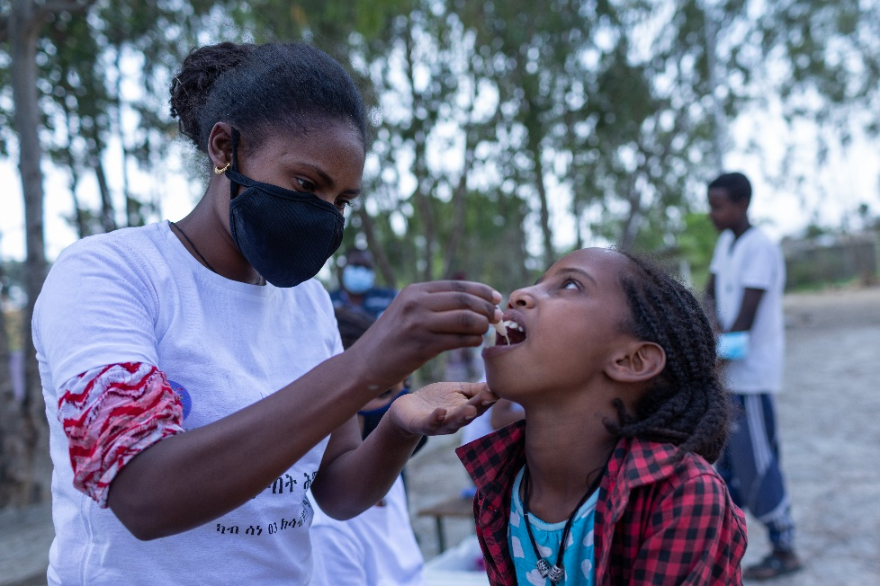
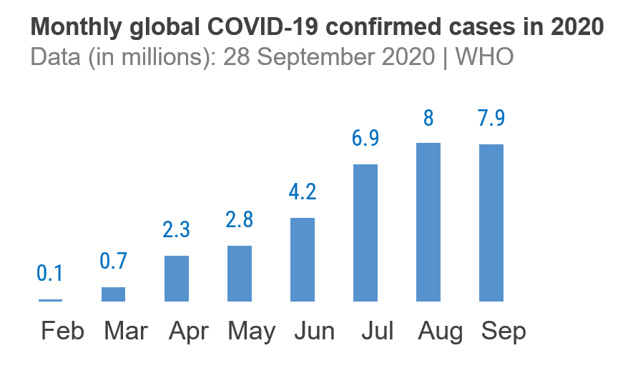

© WHO/Mulugeta Ayene

Nurse Selamawit Araya administers oral cholera vaccine to a girl at Yekatit 23 camp for Internally Displaced People in Mekelle, Ethiopia, during the WHO-supported Oral Cholera Vaccine (OCV) campaign across the Tigray region in June 2021.

IV. Enabling the project: implementing partners (optional)
If the CFE funds were used to implement activities with partners, please complete this section (350 words or less) otherwise leave blank.
- Describe WHO’s collaboration with and role as a trusted health advisor of the Ministry of Health and other government departments.
- Describe how WHO works with its NGO implementing partners. Explain:
  - How NGOs are selected (including an explanation of the context, e.g. sometimes the selection is very limited because of the limited number of NGOs operating in extremely insecure areas).
  - How WHO screens its NGO implementing partners and oversees the quality of their work (e.g. through training and monitoring).
  - How many NGOs have been sub-contracted by WHO and for what purpose.
- Describe WHO’s collaboration with other partners (e.g. joint WHO/UNICEF vaccination campaigns).
- A list of partners can be included in an annex.

> Example: As a trusted health partner by the Government, WHO Indonesia was able to X and Y. To carry out emergency response activities, WHO relied on implementing partners, including national and international non-governmental organizations (NGOs) and other UN agencies.

Two NGOs were identified and selected: NGO A and NGO B. The selection process included X, Y and Z. Quality assurance involved the training of all NGO staff and regular monitoring of performance through spot-checks and regular assessments by WHO staff.

NGO A was sub-contracted specifically to carry out X and Y, while NGO B focused on Z.

Thanks to our long-standing partnership with UNICEF and WFP, activities X and Y were carried out jointly in the three affected provinces, reaching an estimated 100,000 people – of which 25,000 children and 35,000 women.

V. Operational challenges (optional)
Describe any operational challenges and if / how WHO addressed them (350 words or less). These could include:
- Changes in access or coverage of the project (e.g. because deteriorating security led to some project areas becoming off limits to WHO, or because constantly changing conflict lines led to fresh population displacements in new areas).
- NGO implementing partners that ceased health care services, and how subsequent gaps in health care service delivery were filled.
- Lack of skilled health care workers in project areas.
- Logistical and political challenges involved in organizing vaccination campaigns (e.g. maintaining the cold chain, recruiting vaccination teams, and negotiating access with community leaders).

> Example:
Due to X, WHO Pakistan faced the following challenges when planning and implementing activities, and took relevant action to address them:
- Local partners had minimal capacity and access of international staff to the country was limited due to logistical and bureaucratic hurdles. As a result, WHO Pakistan leveraged X and coordinated with Y to ensure a minimum amount of personnel to implement activities.
- Some health facilities were not functional due to roadblocks, lack of running water, and landslides. As a result, WHO Pakistan focused on X and Y to ensure essential medical services could be delivered.
- Health workers were not able to reach populations in need, as transportation and infrastructure had been destroyed. As a result, WHO Pakistan set up X to reach the hard-to-reach.
- Sanctions have resulted in a gradual depletion of medicine stock levels, which will affect most vulnerable and result in an expected increase of preventable mortality and morbidity. As a result, WHO Pakistan worked with X to ensure that the necessary supplies were available in the immediate term.
- There is 92% funding gap for WHO US$ 7 million emergency response plan. As a result, WHO Pakistan has been advocating with partners and donors in the region to mobilize the necessary resources over the next 12 months.

VI. PRSEAH
With WHO’s strong focus on the prevention and response to sexual exploitation, abuse and harassment (PRSEAH), it is important to include in this section any action taken in this area. For example: was a PSEAH action plan be embedded in response activities? Was a PSEAH expert engaged? Was training conducted? Were incidents reported and followed up on? How many? How?

> Example: An international technical expert on PSEAH was deployed through an established standby partner mechanism. Working with national focal points, GBV experts and members of the Inter-agency Standing Committee (IASC), the expert focused on mainstreaming and strengthening protection measures within operations.
Additional resources were utilized to recruit and train six community mobilizers; as well as to develop and distribute prevention posters in the regions of Afar, Amhara and Tigray.

VII. Conclusions and way forward
Use this section to:
- Focus on the final project outcome.
- Highlight the project successes and describe the public health situation at the end of the project.
- Present its overall conclusions, and any plans for continuing the work accomplished, e.g. transition into recovery.
- Note ongoing funding needs.

> Example: The project was timely in ensuring a rapid response to emergency X and filling critical gaps. WHO demonstrated leadership in coordinating action and informing critical decisions based on real-time needs. As a result of the project, X and Y were improved; gaps in X were filled and essential services such as Y and Z were provided.

The health sector coordination mechanism that was established as a result of the emergency is still functional and currently focusing on the COVID-19 response. The action plan developed for the Karantina hospital is currently being implemented by partners in a coordinated manner.

From a funding perspective, WHO was able to secure additional funds from ECHO to complement the critical gap of dialysis supplies and renal disease medications.

At present, WHO is working closely with the Ministry of Health to scale up disease surveillance and fill in gaps of critical medicines to treat patients with communicable diseases in addition to prepositioning supplies for possible outbreaks. As a preventative measure, WHO is also planning to provide hepatitis A and cholera vaccines, as well as rapid diagnostic kits to detect and mitigate outbreaks. To implement these activities, US$ XXX are needed.

VIII. Visibility
In this section, include links to stories, press releases and social media posts related to the activities funded by the CFE (even if not explicitly acknowledged). See an example of human interest story here. Please ensure you share photos via email as an attachment at the highest resolution available (normally ≥ 1 MB is sufficient), including a photo credit and caption (see photo guidance above).

- CHECK LIST

- Are you submitting this technical report within eight weeks of the award end date?
- Did you double-check the dates and amount of the CFE allocation in GSM and inserted them in the “Project summary” section?
- Did you fill out all mandatory sections marked with an asterisk (*)?
- Did you include these key pieces of information: WHY funds were needed, WHAT they accomplished, WHO and HOW MANY people they benefited?
- Did you share photos via email as an attachment at the highest resolution available (normally ≥ 1 MB is sufficient), including a photo credit and caption?
- Did you double-check facts? Statistics? Numbers? Place names?
- Did you ensure that your statistics are backed by sources?
- Did you spell out acronyms the first time they appear in your story (and keep them to a minimum)?
- Did you write full captions for all the photos with the following info: who, what, where, when (and why)? Example: Dr Meseka, WHO Public Health Officer for Nutrition, supervises health workers in a stabilization centre in Western Equatoria State, South Sudan, to improve the quality of nutrition services for children with severe acute malnutrition. November 2021.
- Did you include a photo credit for each photo, including the name of the photographer? Example: © WHO/photographer’s name and surname
- Did you run a spelling and grammar check?

