DRAFT V2_04.02.19
Operations Support & Logistics
CONOPS Guidances
Setting up Concept of Operations


WHE/EMO/OSL
_____________________________________________________________________________________

Concept of Operations
(DRAFT_V1)

Mission |  | Region
Date |  | Compiled by
Email |  | Phone

[This CONOPS template has been provided for instructional guidance only. Sections should be amended/updated depending on the specific context in order to finalize the CONOPS]

A CONOPS is based on information gathered via the OSL field assessment recommendations. It should help the IMS (or Emergency Response Team in case of protracted crisis) to structure its response activities in the immediate aftermath of an emergency. The objectives of the CONOPS are to:
- Describe situational context and why OSL network has been activated.
- Ensure continuity and consistency along the response on OSL directions and associated resource
- Clearly present OSL workplan to ensure proper implementation of Health Response Plan of the IMS team and other relevant stakeholders
- Facilitate input and access to CFE & donors funding mechanisms. It is crucial to reflect specific challenges in the CONOPS (HRP / Supply & Procurement plan of crucial or very specifics commodities / Safety and security constraints / Fleet / EOC, office and staff accommodation set up…
- Support the planning and budgeting exercise

Background
Event/crisis background can be extracted from WHO/IMS Health Response Plan.

WHE IMS Response Plan
WHE’s health response to an humanitarian emergency is focused to prevent and manage outbreaks as well as ensuring the availability of basic health services targeted at preventing and treating common illnesses including for infectious diseases and management of severe acute malnutrition. As an example, the objectives of this scaled up WHO’s health response could be:
- Increase access to essential health and nutrition services
- Strengthen surveillance, early warning and health information management system
- Prevent and control outbreaks
- Establish effective coordination and operations support

Risks assumptions & pre-identified scenario(s)
For the above OSL plan to be implemented we must take into consideration the following:
- Funding will be make available earlier for procurement of planned supplies.
- Technical teams will coordinate with OSL for preparation of proposals and early procurement of supplies.
- Transparent interaction and coordination between the different partners and actors
- The security constraints and the challenging logistics environment (tactical access management)
- The speed of the supply pipeline and its facilitation at International, National and field level

OSL scope & keys pillar’s activities
Based on needs assessment, CONOPS must include a list of objectives and activities as per the OSL pillars & portfolio of core competencies, OSL teams will support the IMS response strategy by:
- Establish security set up according to MOSS compliance standards
- Organize and manage the supply chain cycle management to deliver medical and no medical commodities up to final distribution point
- Set up adequate office space, EOC and staff accommodation and transport
- Provide shared Internet connectivity services to relevant stakeholders
- Support laboratory, IPC and WASH activities
- Implement capacity building efforts to support the current emergency and build resilience for future disasters.
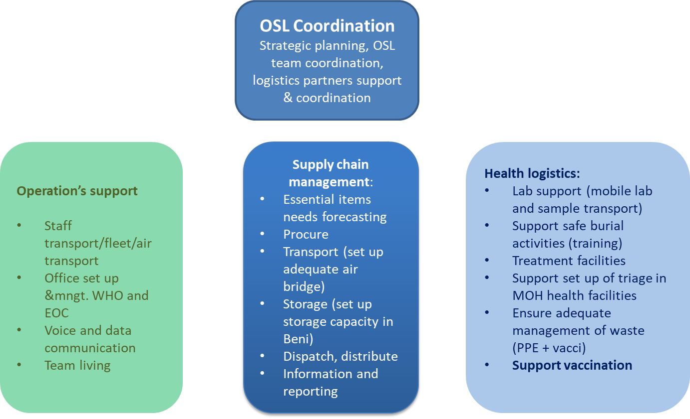

OSL coordination activities:
- Definition and implementation of strategic planning, OSL teams coordination and logistics partners coordination support
- Actively participate in the overall management and planning of the WHO emergency response through providing the Emergency manager with an OSL strategy to ensure the effective integration of logistics operations into WHO's and the Health sector humanitarian response.
- Establish partnerships, operational synergies and coordination of the logistics response to ensure an effective management of the humanitarian response, ensuring close engagement with the national authorities and partners in both the Health and Logistics sectors for all issues including needs and gap assessments and accessibility.
- Capacity building of OSL team through development & implementation of OSL tool, SOPs and guidelines, that orient OSL team to achieve individual and team objectives.
- Implement OSL planned activities and monitor the progress. Regularly update OSL planning in line with overall program dynamics and report on progress.
- Orient and manage the OSL team through regular meetings and reporting. Set objectives for individual team members and evaluate performance of each staff member.
- Development of logistics contingency plan / Business Continuity Plan to support rapid response teams and outbreak investigations.
- Information management and reporting

Operation’s support activities: Providing WHE team adequate and effective operational support and service
- Set up of WHE Office & EOC capacities
- Set up and management of team living capacity (life camp management)
- WHE Facilities management (Offices & warehouses)
- Emergency Telecommunication when emergency set up deployment (voice and Data)
- Fleet management
- Staff transport support (Air bridge support, deconfliction & convoys organisation)
- Enhance operations support for field activities in hard to reach areas
- Refurbishing and equipping of health facilities including installation of medical equipment
- Asset management
- Safety and security

Health logistics activities: Providing WHO health partners with health logistics expertise and onsite support / To support on site health activities and treatment capacity to ensure its adequacy with standard and needs / Support “care for the patients” and Support prevention’s activities:
- Support to surveillance team (mobility)
- Mobil lab set up and management + support lab sample transport
- Designed on Isolation facilities lay out and content
- Isolation facilities set up and management (support to MOH)
- Triage point and patient flow set up in health structure
- Support to safe burial activities
- Reinforcement of universal protection for all health facilities
- Waste management (PPE)
- Support the facilities construction with WHO logistics partners (Other UN logistics capacity)
- WASH & IPC technical support
- Ensure adequate vaccination logistics support (vaccines, ancillaries & Cold chain management)
- Training and capacity building

Supply chain management activities: Management of end to end supply chain for WHE, including development of supplies plan
- Needs forecasting in coordination with technical units (Equipment and consumable)
- Local procurement and petty cash flow management (establishment of procedures for WHE local procurement of goods and & services when needed)
- Custom clearance (implementation of improved importation/clearance model)
- Storage and warehousing (Adequate stock of tents, WASH, energy kits and essential items to set up emergency facilities)
- Transport and distribution: truck, boat, helicopter and plane
- Pipeline monitoring (provide supply chain visibility through pipeline monitoring
- Information and reporting

Note that in highly challenging Health epidemies response, or when there is no active partners in the geographical area of the response, WHO can activate temporary Health partners supply coordination and support activities:

- To forecast the global need in essential medicines and consumables
- To ensure access to essential supply emergency stock
- To coordinate the interagency health emergency logistics task force
- To liaise with health cluster
- To strengthen the MoH supply chain sector

Resources to be deployed
According to our generic organigram (figure below) and the sized response plan, the CONOPS will present a detailed OSL organogram to be implemented and developed.

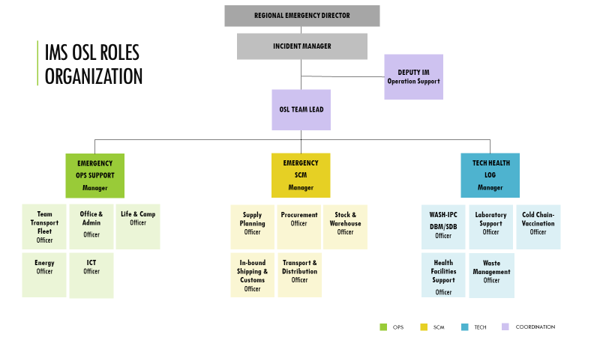

Matrix resources

The matrix resources has to be fully filled up to highlight immediate investment to make IMS & OSL being able to respond on time.
OSL Pillars | HR Existing resources | HR Requested resources | Existing Assets and equipments | Requested Assets and equipments | Comments
OSL Management
OSL OPS
OSL TECH
OSL ESCM

KPIs, budget & annexes
In this section, you will find the templates for completing the CONOPS.

SN | Indicator | Target | Source of verification
1 | Internet connectivity is reliable (no interrupted times and connectivity speed) | 90% & Speed MB per second | OSL weekly SITREP
2 | Percentage of staff with relevant equipment within 48hrs after arrival (computers, Sat phones, generators, VHF/HF & first Aid kit etc.) | 90% | OSL weekly SITREP
3 | Average cost of fleet per KM (USD) | 0.25 < | OSL weekly SITREP
4 | Registered vehicles in TMS | 100% | OSL weekly SITREP
5 | Right sized fleet with average usage rate | 90% | OSL Monthly report
6 | Number of days it takes to order supplies after receiving PTAEO | 01 | OSL weekly SITREP
7 | Percentage of donors proposal are reviewed by OSL | 100% | OSL weekly SITREP
8 | Percentage of procurement plan with corresponding distribution plan submitted to OSL | 100% | OSL weekly SITREP
4 | Percentage of catalogue items delivered within 02 months after PO’s approval | 90% | OSL weekly report
5 | Percentage of non-catalogue items delivered within 03 months. | 90% | OSL weekly report
6 | Percentage of locally procured supplies delivered in 7 working days. | 95% | OSL weekly report
7 | Number of health facilities refurbished and equipped under WHO/XXX project. | XXX% | OSL Monthly report
8 | Warehouses meet minimum standard of good storage and distribution practices | XXX | OSL weekly report
9 | Percentage of health facilities have stock out of one or more essential medicines | 10% < | LMIS/Survey
10 | Percentage of medicines expiring in less than 12 months in WHO warehouse | 5% < | Expiry report
12 | Number of health ministry staff trained on inventory management and supply chain management. | XXX | Training report

Budget summary
SN | Activity | Total cost (US$)
1 | Human resources | xxx
2 | Supplies & equipment (OSL related) | xxx
3 | Running cost for operations support (fleet, fuel, maintenance, internet, guesthouse rent etc.) | xxx
4 | Health logistics (support for SMOH supply chain strengthening) | xxx
Total budget |  | xxxxxx US$
** Budget breakdown is available in attached documents (HR in Operations review, supplies & equipment in 2018 supplies plan, running cost line in running cost budget & SMOH support in concept paper for SMOH supply chain strengthening)

Annexes
SN | Description | Attachment
Annex 01 | Assets/equipment inventory
Annex 02 | Supplies plan for 2018
Annex 03 | OSL activity plan for 2018
Annex 04 | Operations support running cost
Annex 05 | WHE Operations review
Annex 06 | OSL team revised structure
Annex 07 | Concept note for strengthening of SMOH supply chain

