POLICIES AND PROCEDURES

FIN.SOP.II.001
Delegation of Authority in GSM
FNM/ACT
FNM Standard Operating Procedure
Target Audience: All Staff

DISCLAIMER

Standard Operating Procedures (SOPs) provide a step-by-step guide for staff directly involved in the processing of administrative actions to support and facilitate the implementation of WHO policies and procedures. The SOPs are for guidance only; they are neither authoritative nor binding. The SOPs reflect the policies and procedures of WHO at the time of writing; however, policies and procedures change from time-to-time. In the case of a conflict between the SOPs and the WHO eManual provisions, the WHO eManual provisions take precedence.

DOCUMENT SPECIFICATIONS

Version Version | Date of revision | Author (s) / Dept / Unit | Approver | Indicate which section (s) changed compared to previous version
0.1 | Sept 2012 | NARAYANAN, Janaki | STEWART PAPPAS, Jane Margaret; JEFFREYS, Nicholas Richard
1.0 | Feb 2013 | PAUL, Naventhran | STEWART PAPPAS, Jane Margaret; JEFFREYS, Nicholas Richard | Adding additional information, and revised risk section
2.0 | Jun 2015 | HAUSER, Benjamin | n/a minor change | Amendment to 1.2.10 clarifying that requests to grant DOA to RDs and ADGs can also be made by the Comptroller’s office on the basis of appointment notifications sent by the Director General’s office (example provided under 1.3.3)

INTRODUCTION

  - Overview/Description
This document describes the Delegation of Authority (DoA) procedures in GSM including approval hierarchy changes and temporary delegations during periods of absence. This Standard Operating Procedure should be read in conjunction with PRP.SOP.008 Managing Workplan Information at Project Level.

  - General Guidance / Business Rules
- All Major Offices use the GSM delegation of authority system for the management of projects.
- ADGs/RDs, Directors/DAFs, and Coordinators are responsible for determining which officers should receive a given approval level.Assigning approval levels in GSM is coordinated centrally for all Major Offices by FNM at HQ.
- To enable a staff member to approve expenditures in GSM, two steps are required:
- Delegation of authority - A staff member is assigned an approval level. This approval level provides the staff member with the right to exercise a range of financial and HR authorities up to a certain limit, either monetary, or by definition of the task involved. The assignment of approval levels to staff members is coordinated by FNM.
- Assignment of an approval role to a project for the respective staff member - This links the staff member to the project for which the authority will be exercised, and enables the system to send items for approval to the staff member. A staff member cannot become a project approver for a given project without first receiving delegated authority. For details, please see PRP.SOP.II.008 Managing Workplan Information at Project Level.
- All Major Offices follow the same approval levels except for WPRO, EURO and UNAIDS.
- Approval hierarchy can be specified at the Major Office level.
- There is no required interdependence between project approver role and job titles or position grade.
- GSM supports WHO’s delegation of authority and the approval of administrative transactions through automated electronic workflows. However, for certain transaction types (i.e. travel) the GSM workflow may not only be based on project approver levels.
- The delegation of authority in GSM applies to financial matters (incurring expenditure) and HR matters (staffing actions).
    - Approval Levels for WHO (excl. WPRO, EURO and UNAIDS)

Role¹ | Who² | What | Authorized to approve
Project Approver 1 | Usually Programme Officer or Technical Officer | Approves encumbrances and expenditures against projects, including purchase requisitions for goods and services and travel authorizations. | <= $10,000
Project Approver 2 | Frequently be held by a Coordinator | - Approves encumbrances and expenditures against projects, including purchase requisitions for goods and services and travel authorizations  - Also clears staffing actions³. | <= $25,000
Project Approver 3 | Frequently be held by a Director, but could be a Coordinator | - Approves encumbrances and expenditures against projects, including purchase requisitions for goods and services and travel authorizations  - Also clears, and for some tasks (listed in the attachment), approves, staffing actions³. | <= $70,000
Project Approver 4 | Would be held by an Assistant Director-General or by a DG Special Representative | - Approves encumbrances and expenditures against projects, including purchase requisitions for goods and services and travel authorizations.  - Approves staffing actions³. | unlimited

¹ The number of project approver levels can vary between major offices.

² The above levels would typically be assigned to staff at the grades indicated above: however certain situations may exist where a higher, or lower level may be appropriate, for example a technical officer assigned to level 2, or, in emergency situations (see below). In the above levels, "approval" refers not only to the amount of expenditure to be incurred, but also to confirm that activities being carried out are appropriate to achieve the products and results for which they are incurred and use the correct source of funds (are assigned to the correct PTAEO) within the terms and conditions of a donor agreement if applicable.
³ Staff actions include contract extensions, grade changes, terminations etc. A full list, with all actions, and the responsibility attached to each of the 4 approval levels in respect of each, is attached under 1.3.3 below. Following the approval exercised by the project approver, encumbrances and expenditures are subject to administrative checks which ensure that purchasing contracts, staffing actions or travel authorizations meet administrative standards. When contracts exceed set limits, they also are reviewed by the Contract Review Committee.
    - Approval Levels for UNAIDS

Frequently UNAIDS staffs have financial authority against the GSM approval level.
Project approver 1 | Project approver 2 | Project approver 3 | Project approver 4 | Project approver 5
0 - $50k | $50k - $100k | $100k - $200k | $200k -$500k | $500k and above

    - Approval Levels for WPRO

Office | Project Role | Staff Assignment | Authorized to approve
RD/DPM/DAF | Project Approver 1 | NPO | 0.00 – 1.00
 | Project Approver 2 | P3/P4 | 1.01 – 2.00
 | Project Approver 3 | P5 | 2.01 – 10,000.00
 | Project Approver 4 | DAF | 10,000.01 – 50,000.00
Regional Office | Project Approver 1 | PMO | 0.00 – 1.00
 | Project Approver 2 | Team Member/Project Manger | 1.01 – 2.00
 | Project Approver 3 | Project Manager/Team Leader | 2.01 – 10,000.00
 | Project Approver 4 | Director | 10,000.01 – 50,000.00
WR Office | Project Approver 1 | PAO | 0.00 – 1.00
 | Project Approver 2 | PMO | 1.01 – 2.00
 | Project Approver 3 | Project Manager | 2.01 – 10,000.00
 | Project Approver 4 | WR | 10,000.01 – 50,000.00
CLO Office | Project Approver 1 | PAO/Fiji | 0.00 – 1.00
 | Project Approver 2 | PMO/Fiji | 1.01 – 2.00
 | Project Approver 3 | CLO | 2.01 – 10,000.00
 | Project Approver 4 | WR | 10,000.01 – 50,000.00
 | Project Approver 5 | DAF | 50,000.00 - unlimited
    - Approval Levels for EURO

Approval Level | Amount | Who
Level 1 | US$ 0–15 000 | Workplan Manager (= “Project Manager” in GSM)
Level 2 | US$ 15 001–25 000 | Unit Head, Head of Country Office or Head of Geographically Dispersed Office
Level 3 | US$ 25 001–70 000 | Division director
Level 4 | US$ 70 001 and above | Director, Division of Administration and Finance (DAF) based on the endorsement of the recommendation of the Contract Review Committee

Please note that for service requisitions, EURO introduced an additional role (Compliance) so that following approval limits apply:
Role Name | Approval Limit From | Approval Limit To
Project Approver 1 | 0.00 | 14,999.00
Compliance Role | 14,999.01 | 15,000.00
Project Approver 2 | 15,000.01 | 25,000.00
Project Approver 3 | 25,000.01 | 70,000.00
Project Approver 4 | 70,000.01 | 99,999,999,999.00

    - Temporary reassignment of delegation
During periods of temporary absence, up to a maximum of 4 months, temporary re-delegation may be made using the "vacation rules / transfer" function within GSM. No memo is required in this case. This function should not be used to reassign authority longer-term, i.e. when a new approver replaces a previous one. In the case of a permanent replacement, a formal memo should end-date the previous delegation and request required approval level for the new staff member. It is the delegator’s responsibility to revoke temporary re-delegation upon return.

    - Authorizing to “act on behalf of”
Within GSM it is possible to allow another person to submit approvals in the name of the delegated approver. It is important to note that the delegated approver is fully accountable for all actions/ approvals submitted in this way.

    - Assignment of staff to projects in GSM
In addition to the authority to approve certain transactions, relevant staff also needs to be assigned with the required roles in GSM to be able to fully exercise their duties. Workplan managers or project administrators are responsible to assign the relevant “roles” in GSM to the respective staff. Please refer to PRP.SOP.II.008 Managing Workplan Information. For example, to approve a travel request, the approver must not only have the appropriate approval level, but also be assigned as an approver to the project for which the travel is incurred, and be able to access the travel functions of GSM (the relevant assigned role is called "travel approver" in GSM).

    - Emergency situations
Emergencies are managed through special and separate workplans for the emergency, or country office, in the event of a country level emergency. A higher level of approval will be given to the relevant approving officers during the emergency period, in order that the officer can exercise the required temporary higher approval level (for example a WR who has been assigned to approval level 2 would be assigned temporarily to approval level 3). In the event that a separate workplan is not created, the temporary higher approval level will apply to the existing workplan - it is thus important to ensure that separate emergency workplans are created. The standard workflow applies for delegation of authority in emergency situations. For details on emergency procurement procedures, please refer to PRT.SOP.VI.052 Good Emergency Procurement and PRT.SOP.VI.056 Service Emergency Procurement.

    - Signing of donor agreements
Only ADGs/RDs have the authority to sign donor agreements. However, in exceptional cases, this authority can be delegated to their representatives. There is currently no process in place to administer and/or monitor the delegation of the signing authority from ADGs to lower levels of the organization hierarchy.

    - DoA from Director General to ADGs/RDs
Initial delegations of authority from the Director General to ADGs/RDs are produced by the Comptroller’s Office at Headquarters following communication from the Director General’s Office in the form of a memo or appointment email notifications. Please refer to 1.3.3 below for examples.

  - Reference Material
    - WHO eManual
- I.2.4 Secretariat
- II.4.2 Workplan Revisions
- XVII.3.2 Activation of emergency delegation of authority

    - Related SOPs
- PRP.SOP.II.008 Managing Workplan Information at Project Level
- PRP.SOP.IV.001 Donor Agreement End to End
- FIN.SOP.IV.010 Awards End to End
- PRT.SOP.VI.052 Goods Emergency Procurement
- PRT.SOP.VI.056 Service Emergency Procurement

    - Forms and relevant documents
Delegation of Authority Request Form | Annex with details of HR actions and financial limits, and associated required approval level. | Examples of communication from the Director General regarding DOA to RD/ADG

- PROCESS FLOW (to be read in conjunction with PRP.SOP.II.008 Managing Workplan Information at Project Level)
- PROCESS STEPS

Step | Control (C) | Type | Process | Role / Responsibility
1 |  | Offline | Prepares email/memo/ delegation of authority request form asking for a certain approval level.  Of note, the form of the request differs by Major Officer. For HQ, the request form is attached under 1.3.3 should be used. | Requestor Technical Unit
2 | C | Offline | Reviews request and approves by signing if in agreement.  The official signing the request should himself/herself have an approval level which is superior to that being requested, and be the supervisor (either immediate or ultimate) of the staff member for whom the request is made. | Delegation of Authority:  ADG/RD/Director/DAF/ Coordinator  Approval Hierarchy changes:  Comptroller (HQ) / DAF (RO)
3 |  | Offline | Sign the requests and sends approved request to FNM/ACT for assigning delegation.  This represents acceptance of the responsibility that is attached to the approval level.  Please note that in the case of approval hierarchy changes and upon approval of the change, the requestor also needs to work with ITT to create the new hierarchy in GSM. | Requestor
4 | C | Offline | Reviews requests and verifies that it was approved by the appropriate level (Coordinator/Director/DAF/ADG/RD). | Finance Officer ACT
5 |  | GSM | If request was properly approved, assigns requested authority/new approval hierarchies in GSM. If not, follows up with requestor.  For detailed instructions on how to assign authority in GSM, please refer to Annex 1-3. | Finance Officer ACT
6 |  | Offline | Notifies requestor upon assigning delegation. | Finance Officer ACT

- KEY RISKS & COMPENSATING CONTROLS

Risks | Compensating Controls | Process Step
Transactions are approved by unauthorized personnel. | Coordinators/Directors/ADGs review delegation requests and only approve if there is a legitimate business justification.  Finance staff GSC/GFI/AWC verifies whether the request was duly approved. | 2, 4
Activities are not approved by the appropriate staff due to the permanent use of temporary re-delegation thereby bypassing the standard approval process. | Currently not addressed.  Of note, the delegator is responsible for revoking the temporary re-delegation upon return from temporary absence. The permanent use of the temporary re-delegation is not permitted. | n/a  General Guidance
Delegation of authority being used to approve transactions which are not authorized or supported within the framework of rules and regulations of the organisation | There is currently no standard compliance monitoring process across Major Offices.  WPRO and EURO, for example, have changed their approval hierarchy to make compliance checks part of the GSM transaction approval workflow. Headquarters is currently piloting the use of offline checklists to clear service procurement transactions (for now only APWs) above US$ 25,000. For more details, please see PRT.SOP.VI.055 Services Requisition. | See PRT.SOP.VI.055 Services Requisition
Grade and level of staff members not commensurate with the delegation of authority approval levels. | Currently not addressed in a systematic way.  However, it is important to note, that it is the delegation of authority approver’s responsibility to ensure that only appropriate staff are assigned to approval roles/levels. In addition, the official signing the request should himself/herself have an approval level which is superior to that being requested. | n/a  2
Accountability controls not attached with the use of delegation of authority nor is accountability spelt out clearly in case of violation of the delegation of authority | Currently not addressed. | n/a
Review and revoking of staff members who hold delegation of authority and not use it or do not need it is not carried out periodically. | Currently not addressed. | n/a

- ANNEX 1 – ASSIGNING APPROVER LEVELS IN GSM (only for FNM staff)

1. Go to GSM and select “Authority Maintainer” responsibility, then “Maintain Delegation of Authority” role

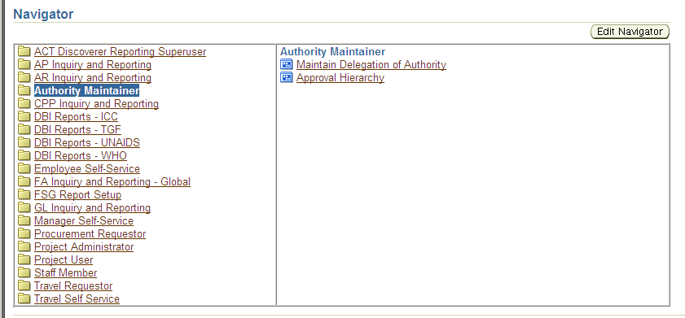

2. Choose the entity, approver role required (Project Approver 1 - 4) and the employee name to whom authority should be delegated.
Click on Find. If the person has not been delegated authority earlier no results will be found and the form will remain blank (see left screen shot). In this case, choose the name once again from the list of values (see right screen).

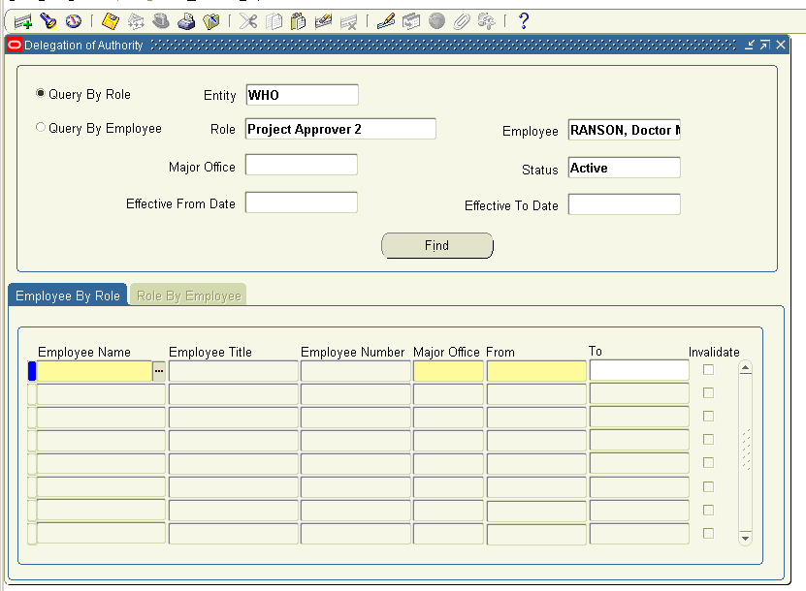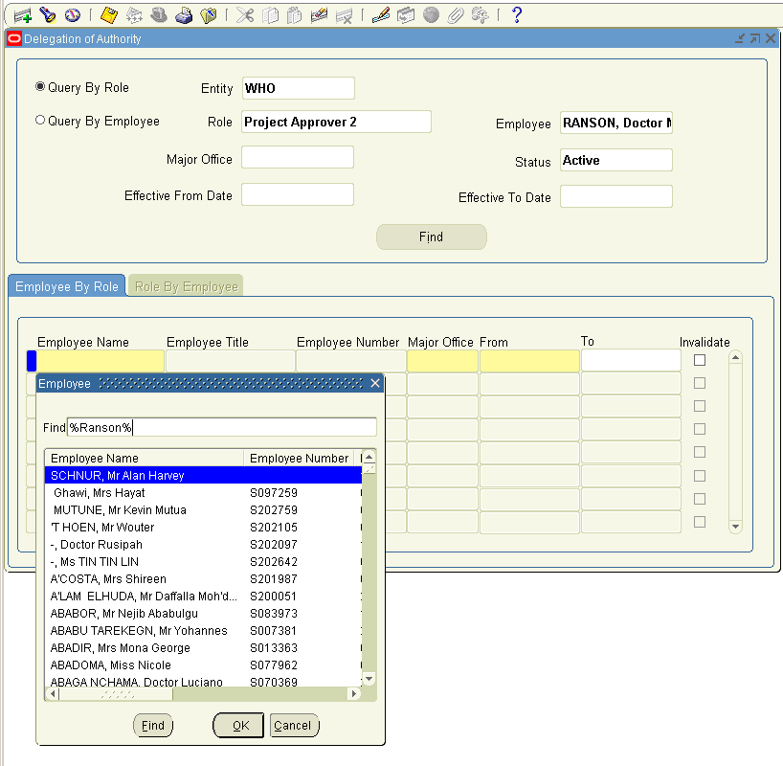
3. Assign MO, and the beginning and end date (if applicable) of the assignment. Save the entry by clicking on the save button.

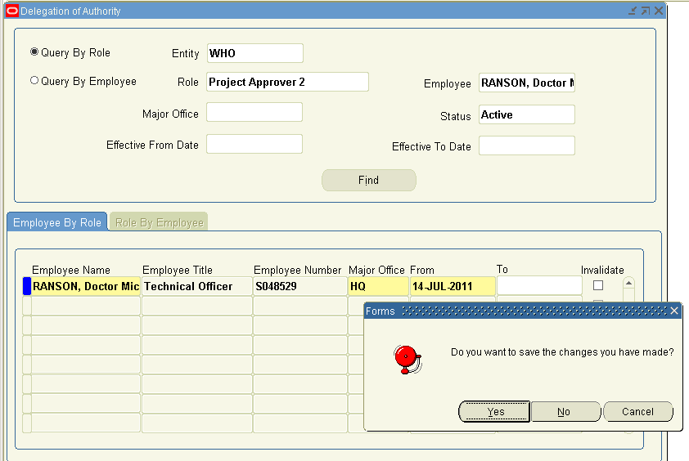

4. The Delegation of Authority request forms are then electronically filed for purposes of audit.
ANNEX 2 – TRANSFERRING WORKPLANS FROM AND END DATED APPROVER TO ANOTHER APPROVER (only for FNM staff)

1. Go to GSM and select “Authority Maintainer” responsibility, then “Approval Hierarchy” role

2. Select “Submit a New Request”, then select report “WHO Delegation of Authority – WHO Transition application”.

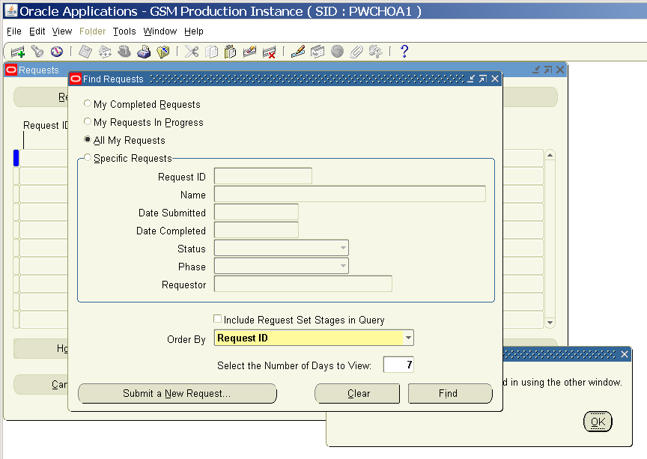

3. Select the role assigned, the staff member who is ending assignment, assignment date for the new staff member and the new staff member’s name. Choose “validate and load” in the validation mode.

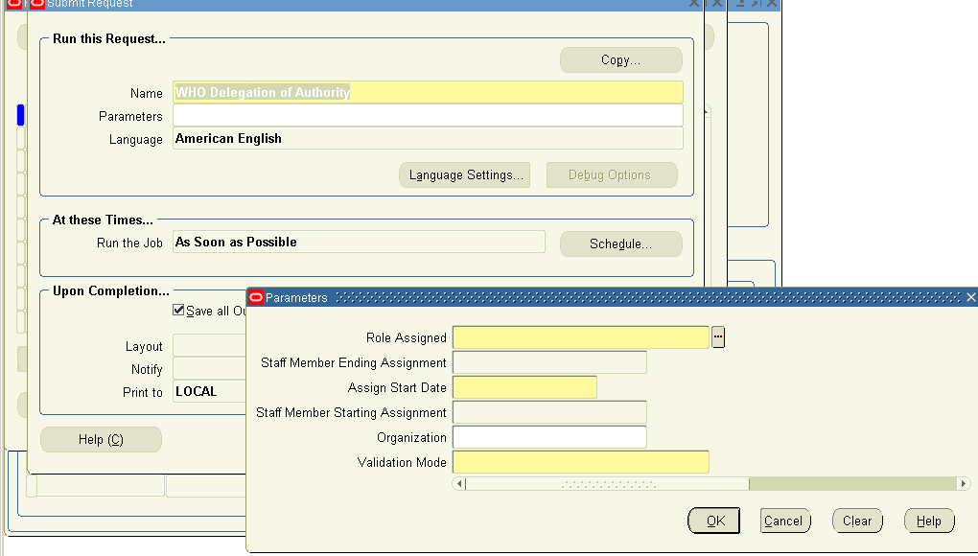

4. Click ok and submit the request. The system then processes the transfer of approval authority of the work plans to the new staff member. Below is a copy of the report summarizing the transfer of work plans from one to the other staff member.

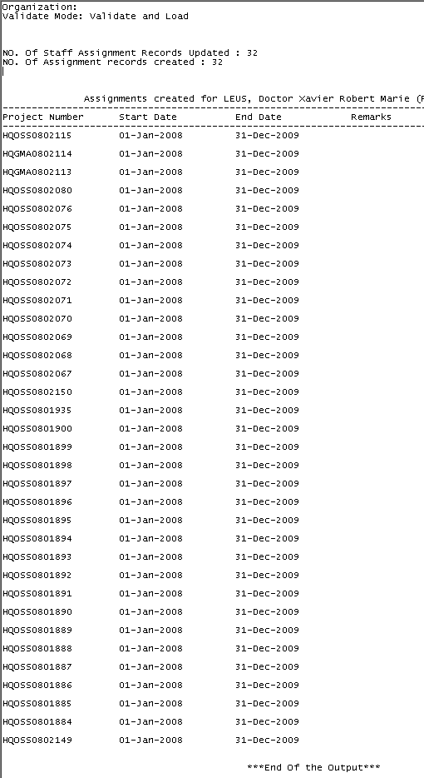
ANNEX 3 – SETTING UP AN APPROVAL HIERARCHY (only for FNM staff)

1. Go to GSM and select “Authority Maintainer” responsibility, then “Approval Hierarchy” role

2. Select Major Office and start and end date of the approval hierarchy. Next, select the module for which the approval hierarchy should apply (under “Source” field). Of note, the approval hierarchy applies to the following modules: Finance, HR, OGA , Purchasing and Travel.

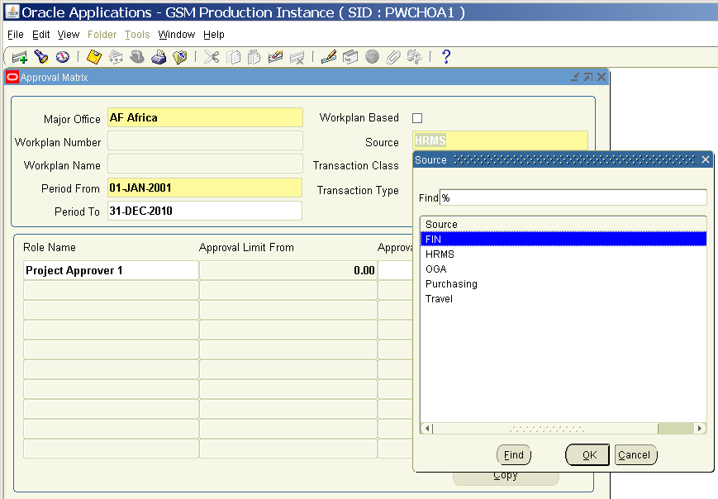

3. Select the transaction class and the transaction type to which approval hierarchy should apply. Of note, major offices determine themselves transaction type and class. The details are added as per the instruction or requests and updated in the forms accordingly.

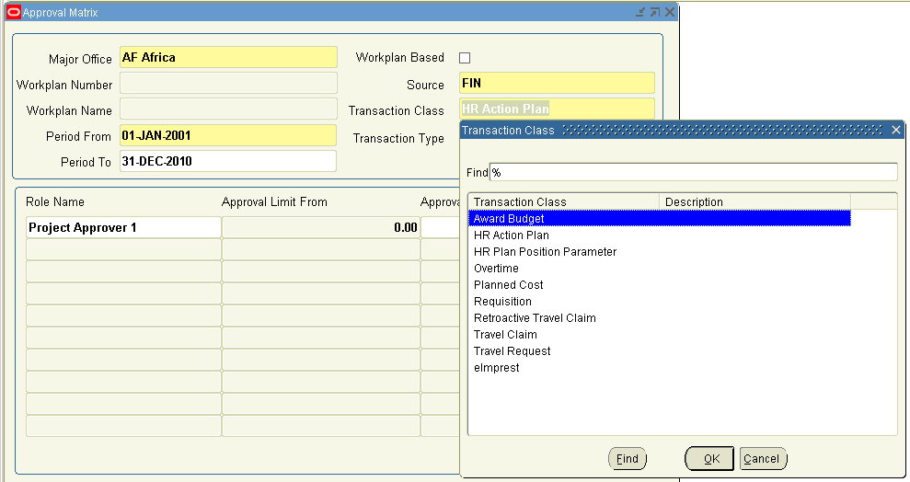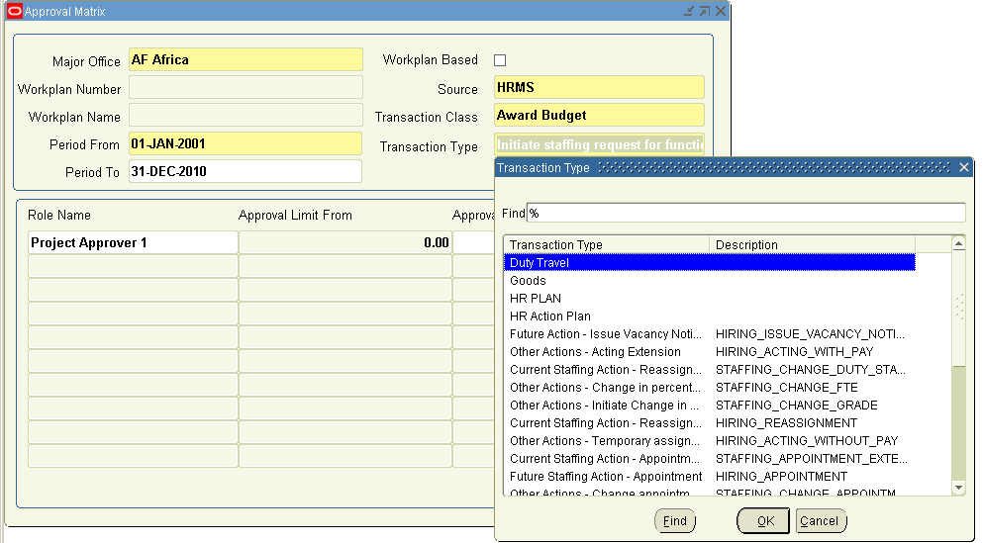

ANNEX 4 – UPDATING THE LOG AND SUPPORTING DOCUMENTATION (only for FNM staff)

- Each delegation of authority approved in GSM should be logged in the Delegation of Authority log.
- Hardcopies of the signed Project Approver requests should be filed according to the effective dates in the log.

