POLICIES AND PROCEDURES

FIN.SOP.X.004
eImprest – Bank and cash account reconciliation
FNM/ACT
FNM Standard Operating Procedure
Target Audience: All Staff

DISCLAIMER

Standard Operating Procedures (SOPs) provide a step-by-step guide for staff directly involved in the processing of administrative actions to support and facilitate the implementation of WHO policies and procedures. The SOPs are for guidance only; they are neither authoritative nor binding. The SOPs reflect the policies and procedures of WHO at the time of writing; however, policies and procedures change from time-to-time. In the case of a conflict between the SOPs and the WHO eManual provisions, the WHO eManual provisions take precedence.

DOCUMENT SPECIFICATIONS

Version Version | Date of revision | Author (s) / Dept / Unit | Approver | Indicate which section (s) changed compared to previous version
1.0 | June 2012 | ZOUMENOU, Euloge (ACT/FNM) | STEWART PAPPAS, Jane Margaret; JEFFREYS, Nicholas Richard
2.0 | Jan 2015 | Bahri, Sameer (ACT/FNM) | Barnabe, Carmelle; Berg, Valpuri | Section 1.2, 1.2.1, 1.3, 1.3.3, 3, 4, Annex 1, Annex 3

INTRODUCTION

  - Overview/Description
This SOP describes the monthly Imprest bank and cash account reconciliation process performed in the eImprest module.

  - General Guidance / Business Rules

    - Reconciliation Overview
The Imprest bank and cash account reconciliation process involves: 1) matching the transactions recorded in the cash book to those recorded in the General Ledger (GL) and 2) matching the bank statement transactions to those recorded in the cash book. Figure 1 illustrates this process.

Figure 1. Bank and Cash Account Reconciliation

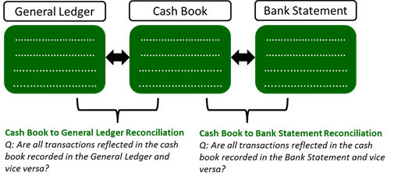
    - Reconciliation Requirements

The following highlights guidelines to be followed/actions to be completed in relation to the reconciliation process:
- The reconciliation is completed in the GSM eImprest module: “Bank Reconciliation” and thus the reconciliation is completed online.

- The Imprest accounts are to be reconciled on a weekly basis and at the end of the month. The longer the period since the last reconciliation, the more difficult it will be to reconcile the recorded transactions and perform the necessary follow-up actions.

- The preparer must enter, on the bank reconciliation page, the month end closing balance as per the bank statement received from the bank for the Imprest bank account. For the Imprest cash account, the amount per the month end cash count certificate is entered.

- For the cash book to bank statement reconciliation, the amount/transaction recorded in the cashbook must match the amount/transaction recorded in the bank statement. Once these items are matched, the box under the “Reconciliation Status” in the reconciliation should be ticked. The word “Reconciled” will now appear next to the transaction. It is important that these items are matched properly, as once the amount is matched and the period is frozen, the item cannot be “unreconciled” if an error is identified.

- For the cash book to GL reconciliation, differences between both balances are to be reviewed, and followed up accordingly.

- In addition to the entries entered in the cash book by the Imprest user, the following external transactions must also be reconciled:
- Entries recorded directly in the GL against the Imprest account (i.e. replenishments made by headquarter or the regional office)
- Payments made by GSC (i.e. travel-related payments, payroll , SHI reimbursements, etc.)

- All transactions are to be reconciled within 90 days/there should be no outstanding transactions greater than 90 days. As per eManual X.3.8 and X.4.3 controlling offices must review Imprest account activities on a monthly basis and ensure that all outstanding items are cleared within 90 days.

- Once the monthly reconciliation is complete, the Imprest account is frozen for the period. This prevents users from entering transactions in the cash book after the reconciliation has been completed. Once a period is frozen, it cannot be unfrozen and transactions can no longer be entered. As such, a period should not be frozen until all reconciling items are identified and all transactions are recorded. Any unreconciled transactions are carried over to the next period.

- The results of the Imprest cash and bank account reconciliation are combined in WHO Form 413 - Monthly Statement of eImprest Account. As such, both accounts should be reconciled before they are frozen (i.e. the cash account should not be frozen until both the cash and bank account are reconciled, and vice versa).

- Once the above is completed, the user assigns a reconciliation rating to the Imprest accounts as follows:
- Rating A: Where an Imprest account has been reconciled, all reconciling items have been identified and no reconciling items are outstanding for more than 90 days.
- Rating B: Where an Imprest account has been reconciled, all reconciling items have been identified but one or more reconciling items have been outstanding for longer than 90 days and less than 180 days.
- Rating C: Where an imprest account has not been reconciled or one or more reconciling items is older than 180 days.

- The results of the reconciliation are important as it serves as the basis for the following month’s replenishment amounts. As such, due care should be employed when performing the reconciliation.

Please refer to Annex 1 for an example of a bank reconciliation page in GSM, Annex 2 for an example of the Outstanding Items Report and Annex 3 for an example of WHO 413: Monthly Statement of eImprest Account.

    - Monthly Imprest Return Submission

As per eManual X.3.6, country offices/Imprest Holders are to submit their completed bank and cash account reconciliations to the respective controlling office as part of a monthly Imprest return submission. The return includes:

- WHO Form 412 - Cash Book Summary;

- WHO Form 413 - Monthly Statement of eImprest Account, duly signed by the preparer of the reconciliation and the Imprest Holder. Support for reconciling items is attached;

- A completed WHO Form 414 – Imprest Account Monthly Checklist, signed by the preparer and the Imprest Holder (refer to 1.2.4);

- A copy of the month end Cash Count Certificate and any Surprise Cash Count Certificates for the month, conducted and signed by the Imprest Holder or other designated member (other than the Imprest Focal Point/Imprest Finance Assistant). An explanation of discrepancies, if any, is also included;

- The month end bank statement;

- Outstanding Items report and a listing of all other outstanding items. An explanation of items outstanding greater than 90 days is provided;

- A copy of the handover documents when there was a change to the Imprest Holder (refer to eManual X.3.10); and

- Other supporting documentation as required.

Original copies of supporting vouchers must be maintained locally, and available for inspection by the controlling office. The Chief Finance or the Regional Office Budget and Finance Officer may determine that original copies should be filed electronically or sent to the controlling office.

    - Oversight and Monitoring Activities
WHO Form 414 should be completed for all lmprest Bank and Cash accounts on a monthly basis. This form contains a list of general verification and assurance type procedures that should be completed to ensure that Imprest policies and guidelines are followed. It is at the discretion of the regional Budget and Finance Officer whether the activities will be completed (and the form filled out) by the country office or the regional office. Section 1.3.4 includes a sample checklist that may be used.

Per the Financial Rules, Imprest Holders are accountable for all funds under their responsibility. As such, it is imperative that the Imprest Holder:
- Approves each payment and signs-off accordingly on the Imprest Vouchers;
- Ensures that the Imprest policies and guidelines are followed and abided by;
- Conducts month end cash counts and a surprise cash count each month; and
- Reviews and approves the monthly Imprest account reconciliations (WHO Form 413);

The Controlling Office (regional Budget and Finance Unit (RO) for country offices / GSC for HQ accounts) oversees and monitors the Imprest accounts. The nature and extent of these activities is determined by the Controlling Office. However, these oversight activities always include reviewing the submitted monthly Imprest return package, verifying the correctness of the reconciliation and reconciliation rating assigned to the Imprest account, and further in-depth oversight activities as deemed appropriate by the Controlling Office.

    - Frequent Reconciliation Issues
A non-exhaustive list of possible reconciliation issues are as follows:
PROBLEM | CAUSE MAY BE | ACTION
A transaction appears on the bank statement but is not in the cash book. | - Mistake by bank /payment is returned / relates to a direct deposit. | Follow up with bank to inquire about the transaction and/or ask for correction/take accounting action as appropriate.
The amount of a transaction in the cash book and the bank statement do not match. | - Bank fees were levied on the transaction.  - Error when issuing the cheque/payment instruction - cheque/payment instruction issued with an amount higher/lower than what was entered in the cash book). | - Record fees if justified.  - For overpayments, claim back money from supplier; for underpayments, issue another cheque/payment instruction to cover the difference.
A cash-to-bank transfer does not appear on the bank statement. | - Mistake by bank. | Follow up with bank.

  - Reference Material

    - Financial Regulations
- Financial Rules - Rule VII – Internal Control – 107.7 and 107.8

    - eManual
- X.3.6 Imprest returns
- X.3.8 Oversight and control
- X.3.12 Year end closure
- X.4.3 Monthly and yearly closure requirements in respect of cash holdings

    - Related SOPs
- FIN.SOP.X.001 eImprest Creation of Accounts
- FIN.SOP.X.002 eImprest Final Closing of Accounts
- FIN.SOP.X.003 eImprest New User Access

    - Forms and Other Material

Sample WHO Form 414

- PROCESS FLOW
- PROCESS STEPS

Step | Control (C) | Type | Process | Role
1 | C | GSM | Reconciles the transactions reflected in the General Ledger (GL) with those in the cash book and ensures that all transactions recorded in the cash book appear in the General Ledger. The difference between both balances is zero. | Imprest User
2 |  | GSM | Enters, in the bank reconciliation page, the month end closing balance as per the bank statement or month end cash count certificate as applicable. | Imprest User
3 | C | Offline | Reconciles transactions recorded in the cash book with those appearing on the bank statement (offline reconciliation). | Imprest User
4 | C | GSM | Based on the offline reconciliation in step 3, reconciles/ticks the transactions that were matched between the cash book and the bank statement in the Bank Reconciliation Page. Records transactions appearing in the bank statement that are not yet recorded in the cash book. | Imprest User
5 | C | Offline | Generates the outstanding items report.Follows up on any items requiring resolution/takes action to clear unreconciled items promptly (always before they reach 90 days outstanding). | Imprest User
6 |  | GSM | Once all differences have been identified and transactions for the month have been recorded, freezes both Imprest Accounts for the period reconciled. Unreconciled transactions are carried over to the next period report until they are reconciled and marked accordingly. | Imprest User
7 |  | GSM/Offline | Completes WHO Form 414 (refer to 1.2.4 above) and prepares the monthly Imprest return package. Assigns a reconciliation rating to the accounts. Submits the package to the Imprest Holder for review and approval. | Imprest User
8 | C | Offline | Reviews and approves the Imprest reconciliations and supporting documents as included in the monthly Imprest return package. Signs both the WHO Form 413 and 414. | Imprest Holder
9 |  | Offline | Submits the monthly Imprest return package to the controlling office. | Imprest User
10 | C | Offline | Reviews submitted monthly Imprest return package and verifies correctness of the reconciliation and reconciliation ratings. | Controlling Office
11 |  | Offline | Replenishes Imprest account. | GSC, BFU or FNM/TSY

- KEY RISKS & COMPENSATING CONTROLS

Risks | Compensating Controls | Process Step
GL/expenditure type coding errors, unauthorized transactions recorded, incorrect application of policies and guidelines. | Monthly reconciliations are performed and reviewed and approved by the Imprest Holder/Controlling Office | 1,3,4,5,8, 10
Misuse of funds due to insufficient account oversight. | The Imprest Holder reviews the reconciliation monthly.  The Controlling Office reviews reconciliation documents as part of the monthly Imprest Return reconciliation. | 1,3,4,5,8, 10
Errors in the reconciliation and the assigned ratings. | The Imprest Holder reviews the reconciliation monthly.  The Controlling Office reviews reconciliation documents as part of the monthly Imprest Return reconciliation. | 8, 10

ANNEX 1
Bank Reconciliation Page
The Bank Reconciliation page displays all the transactions recorded during the period, as well as identifies any unreconciled transactions of the current and prior periods. The GL balance, eImprest balance, bank statement balance and amounts representing the total of unreconciled payments and unreconciled receipts are displayed at the bottom of this page. Transactions are reconciled by selecting the box to the left of each row and selecting the button “Reconcile/Unreconciled and Save”.

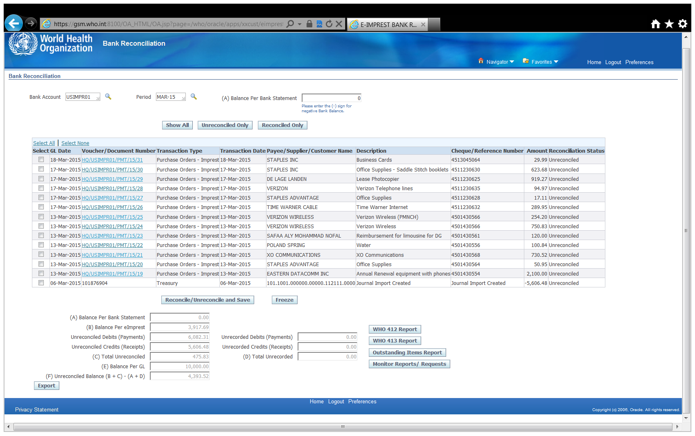
ANNEX 2
Outstanding Items Report
The Outstanding Items Report lists all unreconciled transactions originating from the cash book. All unreconciled items must be reviewed and follow-up conducted to ensure they are cleared promptly.

ANNEX 3
WHO 413: Monthly Statement of eImprest Account
The Monthly Statement of eImprest Account provides a summary of all balances under reconciliation for a particular account. Please note that the bank and cash account are displayed together.
- The GL balance represents the final amount of all transactions posted in the GL ( This amount must correspond to the balance of the eImprest Balance i.e. cash book).
- The eImprest balance represents the final balance of all transactions recorded in the cash book (This amount must correspond to the balance of the GL if the accounts are reconciled).
- Reconciling items under C
- Items in eImprest not in the Bank Statement (debit or credit). Amounts generated by the system based on the reconciliation.
- Items in the bank statement not in eImprest (debit or credit). Amounts generated by the system based on the difference between the Bank Statement and eImprest balances.
- Bank Statement Balance represents the amount entered for the month end bank statement balance.
- Unreconciled balance represents the balance of the cash book and the amount of items in eImprest and not in the bank statement “minus” the balance of the bank statement and the items in the bank statement but not in eImprest .
- Replenishment represents the maximum amount of funds that should be replenished for a given month.

The balance of the cash book is reflected under the name eImprest balance on WHO Form 413: Monthly Statement of eImprest Account.

