POLICIES AND PROCEDURES

FIN.SOP.XII.001
Chart of Accounts Maintenance
FNM/ACT
FNM Standard Operating Procedure
Target Audience: Back Office

DISCLAIMER

Standard Operating Procedures (SOPs) provide a step-by-step guide for staff directly involved in the processing of administrative actions to support and facilitate the implementation of WHO policies and procedures. The SOPs are for guidance only; they are neither authoritative nor binding. The SOPs reflect the policies and procedures of WHO at the time of writing; however, policies and procedures change from time-to-time. In the case of a conflict between the SOPs and the WHO eManual provisions, the WHO eManual provisions take precedence.

DOCUMENT SPECIFICATIONS

Version Version | Date of revision | Author (s) / Dept / Unit | Approver | Indicate which section (s) changed compared to previous version
0.14 | 13.06.2013 | Arbid, Moeen | Rathi, Sushil; Stewart Pappas, Jane; Jeffreys, Nick
2.0 | 07.10.2014 | Arbid, Moeen | Rathi, Sushil; Stewart Pappas, Jane; Jeffreys, Nick

INTRODUCTION

  - Overview/Description
This instruction provides guidance on creating or end-dating segments in the General Ledger Accounting Flexfield.

  - General Guidance / Business Rules
WHO's Chart of Accounts (COA) consists of six segments: Major Office (MO), Fund, Strategic Objective (SO), Budget Centre (BC), Account, and Spare. This is referred to as the General Ledger Accounting Flexfield. Each financial transaction recorded in the General Ledger must be coded with all six segments:

- Major Office: 3 digits - e.g. 101 HQ, 102 AFRO. For expenditure this is derived from the "P" in PTAEO.
- Fund: 4 digits - e.g. 1001 Common Fund, 1111 Assessed Contributions. For expenditure this is derived from the "A" in PTAEO.
- Strategy: 6 digits - e.g. 100001 Vaccines and immunization. For expenditure this is derived from the "T" in PTAEO.
- Budget Center: 5 digits - e.g. 10111 HQODG, 10302 HQHIV. For expenditure this is derived from the "P" in PTAEO.
- Natural Account: 6 digits - e.g. 111101 Cash on Hand, 211101 Salaries Payable. For expenditure this is derived from the "E" in PTAEO.
- Spare: 5 digits always 00000. This account is not in use and is available for future unforeseen needs.

Regular changes to the COA are discouraged, however, certain situations could arise that require an update to the COA i.e. opening or closing a new bank or imprest account, creating a new Budget Center, etc…

Segment Initiaition Event Table:

SN | Segment | Initiation Event
1 | MO | Based on request/memo from Comptroller
2 | Fund | Based on request/memo from PRP or Chief Finance
3 | Strategy | Based on request/memo from PRP
4 | Budget Centre | Based on request/memo from PRP
5 | Account :Imprest or Bank  Account: All other accounts | Based on request from Treasury  Based on a request from BFOs, Unit Heads, Chief Finance, GL Manager
6 | Spare | Cannot be modified/not currently used

  - Reference Material
    - WHO eManual
- XII.3 Chart of Accounts
- X.1.1 Bank Accounts
- X.3.2 Establishment of an Imprest bank account

    - Related SOPs
- FIN.SOP.X.001 eImprest Creation of Accounts
- FIN.SOP.X.002 eImprest Closing of Accounts
- FIN.SOP.X.070 Bank Account Opening/Closing/Signatories

- PROCESS FLOW
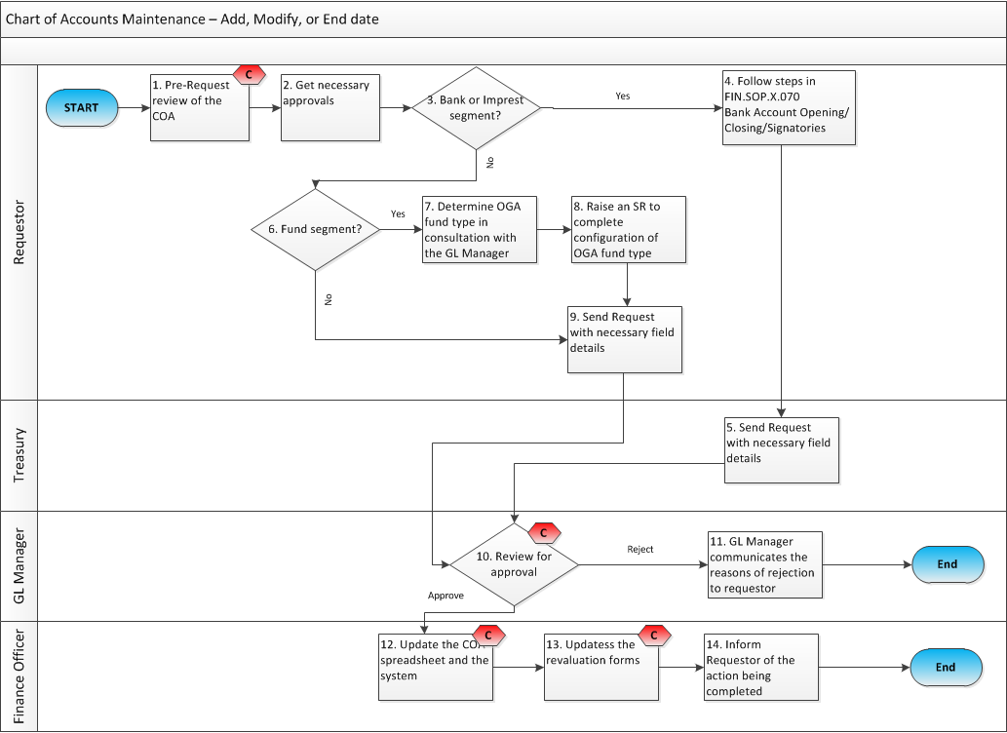
- PROCESS STEPS
Step | Control (C) | Type | Process | Role / Responsibility
1 | C | Manual | Pre-request review to determine the necessary changes to the COA:  - To create a new segment: Review the Chart of Accounts (COA) in order to determine if a new segment is needed, it is preferred that existing segment values are used unless a strong business case warrants the creation of a new segment.  - To end-date an existing segment: Identify if the end-dating of the segment value requires any action to be taken to segment balances and transactions, this is only necessary if end-dating MO, Fund or Account segments. If yes, move the segment balances from existing segment combinations to new combinations by passing a Journal Entry. Also, ensure that there are no pending transactions to be posted to the segment you are end-dating.  - Segment modifications are allowed in exceptional circumstances i.e. to correct an error in the title description or add more clarity to the segment description. Otherwise, modifications are discouraged. | Requester
2 |  | Manual | Get necessary approvals:  - The changes requested to the account segment should be authorized. Segment Values in Oracle shall be created, modified, or end dated based on business requirements. Since each of the segments represent a different business dimension, the Requester should make sure that the initiation part of creating or making changes to segment values are approved by the respective business units (refer to Segment Initiaition Event Table in Section 1.2 of this SOP) | Requester
3 |  | Manual | If the segement to be created is an imprest or bank account, then follow step 4, otherwise, skip to step 6 | Requester
4 |  | Manual | There is a separate process for imprest or bank accounts before requesting their creation in the General Ledger. For this process, please follow FIN.SOP.X.070 | Requester
5 |  | Manual | For imprest and Bank related accounts, Treasury reviews then sends a request to the GL Manager with the necessary PI keys as well as purpose and intended usuage information to allow the creation, modification or end-dating the imprest or bank account segments. Skip to step 10. | Treasury
6 |  | Manual | If the segement to be created is a fund, then follow step 7, otherwise, skip to step 9 | Requester
7 |  | Manual | Determine the OGA fund type code in consultation with the GL Manager | Requester
8 |  | Manual | Raise an SR to configure the OGA fund type in the system | Requester
9 |  | Manual | Send the request and provide the purpose and intended usuage information to allow the creation, modification or end-dating the segments. Also provide a reason for the request. | Requester
10 | C | Manual | GL Manager reviews the request and either approves or rejects the change | GL Manager
11 |  | Manual | If the request is rejected, the GL Manager communicates the reasons of the rejection to the requestor | GL Manager
12 | C | Manual | Based on the receipt of the request/memo, the COA spread sheet and the GSM system are updated by carrying out he following activities:  • Assign an appropriate code to the new segment required in alignment with the code conventions followed for the segment, ensure that the new code is within the appropriate range of accounts to facilitate easier maintenance of various range-based rules such as Cross Validation and Parent-Child relationship.  - For each new value, record the code and the description in the system and fill out required fields i.e. whether 'Posting' and 'Budgeting' are allowed for the segment value to be created or in case of a new natural account, specify the Account Type i.e. whether it is an Asset, Liability, Owner’s Equity, Revenue or Expenditure based on the nature of the account.  - Attach the new value to the appropriate Parent value. This will be automatically achieved, where a range based relationship is followed.  - Where the new value being defined is a Parent value, attach appropriate child values and attach a Roll-up Group if the new parent account has to be used in a Summary Template.  - Run the following programs:  a. Program - Incremental Add/Delete Summary Templates  b. Program - Maintain Summary Templates  • For end-dated segments only, fill out the “To” field with the last date where the segment could be used. Cross out the line of the end-dated segment on the COA spread sheet. | Finance Officer
13 | C | Manual | If necessary, update the revaluation forms for newly created natural account segments | Finance Officer
14 |  | Manual | The Requestor is informed of the action being completed | Finance Officer

- KEY RISKS & COMPENSATING CONTROLS
Risks | Compensating Controls | Process Step
End dating a Balance Sheet account without clearing the remaining balance in that account | Review account balance before submitting the COA Request | 1
Creating an account when an existing account could be used instead | Review the COA before submitting the COA Request. Also the GL Manager reviews the request before approving it. | 1 & 10
Creating a segment incorrectly | The created segment is sent back to the Requester for review | 12
A newly created Account segment is not added to the revaluation forms | Periodically, the COA is compared to the list of Accounts that gets revaluaed. | 13

