POLICIES AND PROCEDURES

OSS.SOP.XIII.003
Property (Land & Buildings)
GMG/OSS/ISS
OSS Standard Operating Procedure
Target Audience: All Staff

DISCLAIMER

Standard Operating Procedures (SOPs) provide a step-by-step guide for staff directly involved in the processing of administrative actions to support and facilitate the implementation of WHO policies and procedures. The SOPs are for guidance only; they are neither authoritative nor binding. The SOPs reflect the policies and procedures of WHO at the time of writing; however, policies and procedures change from time-to-time. In the case of a conflict between the SOPs and the WHO eManual provisions, the WHO eManual provisions take precedence.

DOCUMENT SPECIFICATIONS

Version Version | Date of revision | Author (s) / Dept / Unit | Approver | Indicate which section changed compared to previous version
1 | Mar.13 | J.Scanlen OSS/AMG | Bruce Leech, OSS/AMG;  Richard Preston | Document creation and process
2 | May.13 | J.Scanlen OSS/AMG | Bruce Leech, OSS/AMG;  Richard Preston | Capitalization of subsequent expenditure
3 | Aug.13 | J.Scanlen OSS/AMG | Jane Stewart | Accounting data updated
4 | Mar.14 | J.Scanlen OSS/AMG | Sushil Rathi | Process and treatment of LT interest free loans for the construction of new buildings
5 | Oct.14 | J.Scanlen OSS/AMG | Sushil Rathi | Updated layout and addition of templates
6 | Jan.15 | J.Scanlen OSS/AMG | Sushil Rathi | Swiss Loan accounting calculator
7 | Oct.16 | J.Scanlen OSS/AMG | Sushil Rathi | Warehouses added as a category - useful life
8 | Mar.25 | J.Scanlen OSS/AMG |  | To reflect the new cap asset and leases threshold of $20k

  - Overview

The purpose of this document is to describe the accounting practice and procedures relating to Property (Land and Buildings), and to facilitate compliance with the WHO Manual, WHO IPSAS policy and the requirements of the International Public Sector Accounting Standards (refer to the following standards: IPSAS 13-Leases, 17-Property, Plant and Equipment, and 23-Revenue from non-exchange transactions).

  - Categories of Land & Buildings

a. Property (Land and Buildings) owned by WHO

Under IPSAS, ownership is recognized when WHO has both
Title and control.

Land: WHO IPSAS policy is to disclose Land owned by the Organization at its original purchase cost.

Land is not depreciated as its life is considered infinite.

Buildings: WHO IPSAS policy is to disclose buildings owned by the Organization as follows:

- When purchased - at the original purchase price, less accumulated depreciation,

- When self-constructed – at the historical cost to construct and place in service, less accumulated depreciation.

For the purposes of calculating depreciation, WHO currently uses:

- 60 – 100 years as the useful life for buildings
- 15 years for warehouses
- 5 - 10 years for temporary or mobile structures

b. Premises leased (rented) by WHO

Under WHO policy for IPSAS 43, a USD 20,000 threshold will be used for leases calculations.

Leases data is obtained and recorded by PWC, who are responsible for providing HQ/FNM with the required accounting entries, Tables and Notes, for the WHO Financial Statements, commencing in 2025.

c. Premises granted to WHO to use, at no cost

Under IPSAS 23, WHO is required to disclose the ‘in-kind’ value of premises granted to WHO (donated right to use).

The “in-kind” value, represents the equivalent market rent for similar premises, (i.e. the rental that WHO is not having to pay). Similar premises refers to those of the same or similar size, location and condition.

Where this is not easily obtainable, an estimation is to be made using the best available evidence

WHO IPSAS policy is to disclose premises and/or office space where the equivalent market rent is at least USD 20,000 per annum.

For more details on reporting in-kind contributions, refer FIN.SOP.IV.013 In Kind and In Service Awards

Donor agreements for these premises are to be forwarded to HQ/FNM/ACT.

d. Land granted to WHO

IPSAS also requires WHO to disclose land granted to the Organization for the purposes of
- constructing premises, or
- when purchasing premises.

WHO IPSAS policy is to disclose relevant details in the Financial Report, within the Notes to the Accounts.

3. Improvements to Land & Buildings

a. Property (Land and Buildings) owned by WHO

Expenditure on WHO Land and Buildings falls into two categories.
These categories are important because the accounting treatment will be different

- Costs that qualify for capitalization

Under the recognition principle of IPSAS 17, WHO will capitalize improvements/subsequent expenditure when the service potential of the property has been increased. WHO has defined the following conditions to determine when this occurs.

Only when all these conditions are met will the expenditure be considered for capitalization:

- The useful life or the useable space of the building will be increased
- The improvement will be permanent (i.e. not intended as a temporary change to the building)
- The project cost exceeds USD 100,000
- The project costs are paid directly by WHO
- The project will be considered part of the building structure (i.e. not separable)
- The project cost must exclude equipment recorded and tracked in the Fixed Assets module.

- Costs that are expensed when incurred

Under the recognition principle of IPSAS 17, WHO will expense the following:

- Day to day servicing costs
- Scheduled or programmed maintenance
- Non-scheduled repairs to bring an asset that is part of the building structure back to its original condition (e.g. major repair after an accident), and that do not significantly increase the building’s useful life or service potential.

- Building Maintenance

WHO operates a policy of programmed preventative maintenance of buildings.

Day-to-day scheduled maintenance is carried out to mitigate the impact of normal wear and tear on building components.

Whereas WHO has established a useful life of 60 - 100 years for buildings (and 5 – 15 years for mobile or temporary building structures), many individual building components will require multiple instances of maintenance and repair during this sixty year period.

These maintenance or like-for-like replacement costs are expensed because they do not increase the useful life or service potential of the buildings as a whole, but contribute to the achievement of the established 60 year useful life of a building.

Scheduled maintenance alone cannot prevent obsolescence or remove the need for eventual replacement or renovation of the building. When this occurs, the costs involved are capitalized because the investment undertaken can reasonably be understood to increase the useful life and service potential of the building, often through changes in layout, wholesale replacement of building infrastructure or the addition of extra space.

An indicative, non-exhaustive matrix of different project types is detailed in the table below, together with guidance on whether the costs should be recognized as subsequent expenditure and capitalized, or expensed in the period in which they occur.

- Building Maintenance Matrix

Type of work | Satisfies all conditions for capitalization Yes/No | Accounting treatment
Installation of heating, cooling, ventilation, water, electrical, drainage, sewerage, IT networks, fire detection and suppression systems where none existed before | Yes – if the useful life of the building is increased | Capitalize | Infrastructure
New construction of annexes or extensions, major renovation of existing buildings where complete infrastructure systems (electrical, heating, cooling, and ventilation) are renewed with improved materials or components. | Yes – new constructions if they increase the space available or, the improvement results in WHO being able to extend its useful life | Capitalize | renovation
Installation of MOSS compliancy or other security infrastructure where none previously existed (alarm systems, perimeter walls) | Yes – if the useful life of the building is increased | Capitalize | security
Repair and partial like-for-like replacement of existing installations of heating, cooling, ventilation, water, electrical, elevators and escalators, drainage, sewerage, fire detection and suppression systems, IT networks, | No – the work does not increase the service potential or useful life but facilitates continuous use in accordance with the original useful life. | Expense | No reporting
Scheduled preventative maintenance (testing, fault detection/diagnostics and remedial works, servicing, lubricating, sealing, caulking, filter and belt replacement, re-filling, re-charging, re-lamping, adjusting, cleaning) of existing installations including: IT networks, heating, cooling, ventilation, water, electrical, drainage, sewerage, fire detection and suppression systems, elevators and escalators. | No - the work does not increase the service potential or useful life but facilitates continuous use in accordance with the original useful life | Expense | No reporting
Maintenance or repair constituting partial, like-for-like replacement of building components such as: painting of windows, doors, walls, ceilings, floors, floor coverings, roofs, basements, built-in cupboards, partitions | No – the work does not increase the service potential or useful life but facilitates continuous use in accordance with the original useful life. | Expense | No reporting
Cleaning, pest extermination, grounds maintenance/gardening, interior/exterior decoration and statutory testing. | No - the work does not increase the service potential or useful life but facilitates continuous use in accordance with the original useful life | Expense | No reporting
b. Property (premises) rented/leased or granted free use of to WHO

WHO will capitalize significant expenditure on rented (leased), or those granted free use of to WHO, when all the following conditions have been met:

- WHO is a signatory to -
  - the rental/lease agreement or,
  - to the agreement that specifies WHO can occupy premises at no charge (or at a subsidized rate)
- the cost of each improvement (project) is USD 100,000 or more
- the improvement clearly increases the service potential of the premises to WHO
- the improvement is paid for by WHO
- the improvement is used by WHO
- the improvement is controlled by WHO
- the improvement is not a separable item(s) of equipment recorded and tracked in the Fixed Assets register but is part of the permanent structure of the premises, such as
  - additional office space
  - significant plumbing, electrical or communication improvements
  - major roofing or flooring work
  - major building renovation projects
- the improvement will be used for more than 12 months
- the non-cancellable portion of the ‘lease term’ at 31.Dec. is greater than one reporting period, or 12 months
- the improvement reverts back to the lessor/donor when WHO vacates the premises
- the lessor/donor has the option to require that WHO dismantles the improvement at any time
- WHO has the responsibility to maintain the improvement (and not the lessor/donor)

If any of the above conditions are not met then the expenditure is to be expensed in the financial period incurred.

Period of capitalization:
Depreciate the cost of the improvement over the minimum lease term (non-cancellable portion), up to a maximum of ten years (as decided in conjunction with HQ/FNM/ACT and HQ/OSS/AMG).

4 Tracking and reporting requirements

Each office must maintain good financial records of all premises being used or controlled by the Organization.

This covers the following types of premises used by WHO:
- existing WHO owned property
- new WHO property under construction
- premises rented/leased or granted free to WHO

These financial records are to be kept updated by each office during the year using the templates provided in Annex 1, and forwarded to the Regional Office for review in advance of the timelines below.

a. Improvements to existing property owned by WHO (template 1)

Each Office owning premises is to track and report the details of all expenditure over USD 100,000 during the year.

This expenditure excludes new equipment recorded and tracked in the fixed assets database.

The completed expenditure template is to be reviewed and classified by the Regional Office ASO and BFO teams and forwarded to
HQ/OSS/AMG by 30 November (refer Annex 1 template 1).

b. Construction in progress (CIP) of new WHO owned property (template 2)

Expenditure on new constructions is to be tracked and recorded on template 2 CIP

This expenditure excludes new equipment recorded and tracked in the fixed assets database.

The completed expenditure template is to be reviewed by the Regional Office ASO and BFO teams and forwarded to
HQ/OSS/AMG by 30 November (refer Annex 1 template 2).

c. Improvements to property (premises) rented/leased or granted free use of to WHO (template 3)

Improvements to premises meeting the criteria under section 3.b are tracked using template 3.

This expenditure excludes new equipment recorded and tracked in the fixed assets module of GSM.

The completed template is to be reviewed and classified by the Regional Office ASO and BFO teams, and forwarded to
HQ/OSS/AMG by 30 November (refer Annex 1 template 3.

d. Updated Rental/Lease information for premises rented/leased or granted free use of to WHO (template 4)

Annual rental cost data for leased premises, and equivalent rental values for premises granted free to WHO are to be reviewed and tracked by the Regional Office ASO and BFO teams, and forwarded to HQ/OSS/AMG by 30 November
(refer Annex 1 template 4).

This timeline is earlier due to the requirement to account for the ‘in-kind’ value of donated premises, as described in section 2.c. However it is prudent to be pro-active and review these datails well in advance of the 30 November deadline and forward the completed template by 30 November.

5. Depreciation process. (Transition accounting process: HQ buildings have been input into the FA module and depreciation is accounted at month end, as for capitalized equipment. RO building depreciation is input to the GL at year-end during transition). NB. This is a process completed by HQ only.

a. WHO owned property – purchased or constructed.

- Historical cost data, supported by good documentation as the base.
- The life cycle for the depreciation calculation is 60 – 100 years.
- Depreciation is calculated using the straight line method, as for all other WHO fixed assets (equipment).
- For buildings placed in service before 2012, depreciation commences from Jan.1 in the year placed in service
- For buildings placed in service from Jan 1, 2012 depreciation is calculated per WHO policy, as detailed in section XII.2.5 para 100 of the eManual
- For a new building construction, the cost base used is the final total cost to place the building in service, excluding all administrative overhead costs.

Example: Building constructed by WHO during 1966-67 and placed in service in late 1967, on land donated to WHO.

Land: not capitalized/recognized as a fixed asset (property) in the accounts, as WHO does not have title and control

Building: historic cost (local currency costs converted using documented historic exchange rates)
USD 12m documented construction costs
USD 1m documented architects fees
USD 1m documented ancillary costs to place the building into service
A USD 14m Historic Total Cost

depreciation (calculated from Jan, 1 of the year the building was placed in service, i.e. 1967)
USD 14m/60 years = USD 233,333 p.a.
B USD 10.5m Accumulated depreciation (from 1967 to 2011 inclusive = 45 years x USD 233,333)

A-B USD 3.5m Carrying Amount (or Net Book Value)

Accounting action by HQ/OSS/AMG -

- to account for the period: placed in service to end 2011

A Dr: MO/Account 181001 USD 14m buildings cost account
Cr: MO/Account 300001 USD 14m fund balance - building cost

B Dr: MO/Account 300001 USD 10.5m fund balance - accumulated depreciation
Cr: MO/Account 189001 USD 10.5m accumulated depreciation

- to account for the period: from 2012 to when depreciation is complete

each month GSM will post the following automatic entries to the GL

B Dr: MO/Account 581001 USD 233,333 monthly depreciation expense account
Cr: MO/Account 189001 USD 233,333 monthly accumulated depreciation

b. Capital improvements to WHO owned property.

Depreciation will commence from the beginning of the month from when a capital improvement has been placed in service.

Depreciation will be calculated over the estimated remaining life of the building.

Accounting action by HQ/OSS/AMG -

- A to account for CIP during the works:

Dr: MO/Account 181201 USD 1.0m construction costs (in progress)
Cr: MO/Account 580008 USD 0.6m exp code 513 contractual services,
Cr: MO/Account 580009 USD 0.4m exp code 519 gen.op. expenditure

- B to account for the works when placed in service:
Dr: MO/Account 181101 USD 1.0m new building
Cr: MO/Account 181201 USD 10.5m construction costs (in progress)

c. Capital improvements to WHO property (premises) leased/rented or granted free to WHO (donated free use of).

The capitalization process will be managed by HQ upon receipt of good documentation, and the costs will be depreciated over the lower of:

- the remaining non-canceleable portion of the lease/donor agreement, or
- 10 years

Depreciation will commence from the beginning of the month from when a project was placed in service.

- 6. Reference material

  - FIN.SOP.IV.013 In Kind and In Service Awards
  - OSS.SOP.XIII.002 Asset Management
  - OSS.SOP.XIII.006 Premises
  - OSS.SOP.XIII.008 Leases

- 7. Process flow

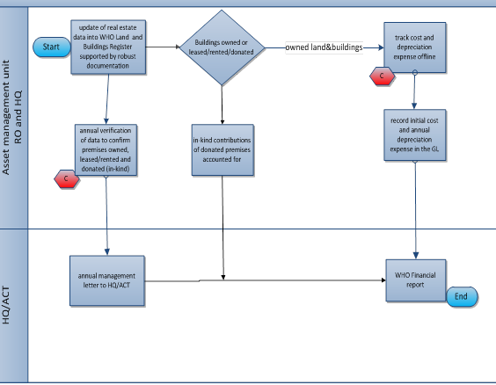

8. Process steps

9. Key risks and compensating controls

10. Annex 1

Template 1 Improvements to existing property owned by WHO
Due date in HQ/AMG 30 November

English version Version français

Template 2 Construction in progress (CIP) of new WHO owned property
Due date in HQ/AMG 30 November

English version Version francais

Template 3 Improvements funded by WHO for premises:
a. rented/leased by WHO or
b. granted free use of to WHO.
Due date in HQ/AMG 30 November

English version Version français

Template 4 Premises Template covering:
a. rented/Leased or
b. granted free use of to WHO
Due date to HQ/AMG 30 November

English version Version francais

Annex 2 Long Term borrowings – (for HQ/OSS/AMG only)

a. Process

In certain locations WHO may be granted an interest-free loan facility to fund construction of a new building. Under IPSAS, WHO needs to implement appropriate accounting processes in the following areas to ensure full compliance:

  - The value of the interest-free portion of the loan (considered an ‘in-kind’ contribution)
  - The adjustment to fair value (considered an unrealized exchange movement)
  - The annual loan repayment (calculation of principal and interest portion)

The basis for the calculation of the above is the use of an interest amortization schedule (refer section d below), a straight-line schedule representing equal annual payments for the duration of the loan.

The following two key inputs enable the GL accounting entries (3. and 4. Below) to be derived from the schedule:

1. The market interest rate to use (for HQ, the Swiss franc 30 year Bond rate as published by the Swiss National Bank, as at Dec.XX)
- This is the minimum interest rate that WHO would pay if the loan was obtained commercially

2. The exchange rate as at 01 January (for HQ, the CHF:USD rate)
- This is the UN exchange rate applicable on Jan. 01 of the following year, i.e. 01 Jan.2015 if calculating for 2014

3. The GL balance of account 250102 (LT Borrowings) before posting the annual loan repayment to the GL

4. The GL balance of account 250102 (LT Borrowings) after posting the annual loan repayment to the GL

b. Calculation steps

Taking as an example, the calculation for 2013: Steps 1 to 4

1. CHF 30 Year Corporate Bond rate as at Dec.13 (source: www.snb.ch/ext/stats/akziwe/pdf/defren/Geld_und_Kapitalmarktsaetze.pdf)

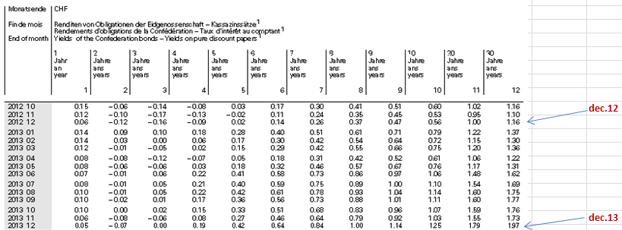

Dec.13 Swiss franc 30 year bond rate = 1.97% (Dec.12 = 1.16%)

This means that the cost of a commercial loan increased during 2013 to a minimum rate of 1.97% at year-end. This represents the basis for calculating the value of the ‘in-kind’ contribution in 2013 of the interest-free loan, which under IPSAS, WHO must disclose in the Annual Financial Report.

2. UN exchange rate

1 CHF = USD 0.887 as at 1 January 2014 (this most closely approximates the actual exchange rate as at 31.12.2013)

3. GL Balance of account 250102 - before posting the current year loan repayment (2013)

USD -22,782,082.35 (credit balance in 101.1001.000000.00000.250102.0000)

4. GL Balance of account 250102 – after posting the 2013 loan repayment

USD value of 2013 loan repayment = USD 674,182.64 (CHF 598,000)
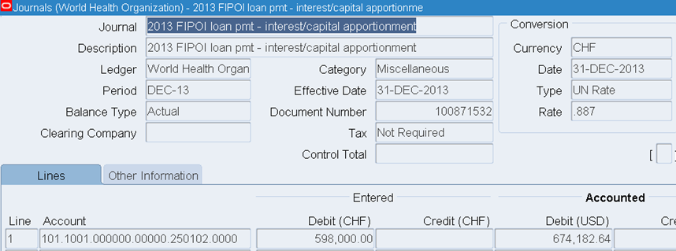

Account balance 250102 after 2013 loan repayment was posted:
USD -22,107,899.70

With the data produced from steps 1 to 4, the amortization schedule can now be utilized to calculate steps 5. 6. and 7 below.

5. The USD value of the interest-free portion of the loan

annual payment less amortized capital portion for 2013 (calculated from the amortization schedule each year)
chf 598,000 less chf 263,547.91 = chf 334,452.09 chf 334,452.09/0.887(X rate on 1.Jan.14) = USD 377,060
USD 377,060 is the value of the 2013 ‘in-kind’ contribution

6. The adjustment to fair value: accounting for the unrealized gain/(loss) in WHO’s USD LT liability

This is a two step process that will result in the recognition of an unrealized exchange gain/(loss) during the year.

Part 1: Obtaining the PV (from the amortization schedule) of the interest income if the principal was invested over the remaining life of the loan, at the December 2013 30 yr. chf bond rate.

This represents the gain to WHO of not having to pay interest on the loan, and is therefore deducted from the residual loan balance, stated in USD, in the LT liability account, 250102.

Using the amortization schedule gives a total for 2013 of CHF 8,138,736.45 which at the 1 Jan.14 X rate = USD 9,175,576.61

Therefore, the PV of the interest = USD 9,175,576.61 if the residual value of the loan was invested at the 30 yr. bond rate over the remaining life of the loan.

Part 2: Calculating the gap between the USD value of residual balance of the loan and the USD GL balance in the LT liability account 250102. The aim is to determine the potential financial impact if the loan had to be repaid on 31 December each year and compare this USD amount to what has been accounted for in the LT liability account.

- Residual value of loan at 31.Dec.2013 = CHF 25,714,000 = USD -28,989,853.44
- Balance at 31.Dec.2013 in account 250102 (step 4 above) = USD -22,107,899.70

Difference to account for under IPSAS = USD -6,881,953.74

Summary: Therefore the method to account for the difference between Part 1 and Part 2 is:

Dr: the PV of the interest not being paid (part 1) = USD 9,175,576.61
Cr: the difference in the LT liability (part 2) per IPSAS = USD -6,881,953.74

Unrealized gain/(loss) in the WHO LT Liability = USD 2,293,622.87

7. The annual loan repayment (calculation of principal and interest portion)

In 2004 the Swiss Confederation through FIPOI (La Fondation des Immeubles pour les Organisations Internationales) granted WHO a 50 year interest-free loan of CHF 59.8m to pay for the construction of a new building to house WHO and UNAIDS staff at HQ.

The repayments are split 50:50 between WHO and UNAIDS and are payable by 31 December each year, in 50 equal instalments. The first payment being made in 2007, shortly after the building was placed in service.

Using the amortization schedule in section d below to determine the split for 2013 between the capital and interest portion of the annual CHF 598,000 annual repayment shows:

Capital chf 263,547.91
Interest chf 334,452.09
Total chf 598,000.00

c. Accounting

- The in-kind contribution that represents the value of the interest not being paid.

For 2013 this was calculated in step 5 above as USD 377,060

Required accounting steps:

  - Create an ADR in order for the distribution to be increased
  - Submit the workplan funding to GSC
  - Submit the award budget after validated against planned costs to GSC
  - Submit the financial AMR for the level required to cover the USD 377,060 to GSC
  - Adjust the baseline if required
  - Input 1 line expenditure batch – credit entry of USD 377,060
  - Prepare and post USD journal to clear OGA and credit contributions in kind account
Dr: 101.1001.000000.00000.243003.0000
Cr: 101.2011.000000.00000.412003.0000

- The adjustment to fair value and posting of the unrealized exchange gain/(loss)

For 2013 this was calculated in step 6 above USD 2,293,622.87

Dr: 101.1001.000000.00000.250102.0000 USD 9,175,576.61 “adjustment effective interest method 2013 loan”
Cr: 101.1001.000000.00000.250102.0000 USD 6,881,953.73 “adjust for fair value 2013 loan”
Cr: 101.1001.000000.00000.575201.0000 USD 2,293,622.87 “unrealized gain acc 250102 for 2013”

- The annual loan repayment

For 2013 this was calculated in step 7 above

Prepare and post a LC journal in CHF using the exchange rate as at 1.Jan.2014 of 0.887

Dr: 101.1001.000000.00000.250102.0000 CHF 598,000.00
Cr: 101.1001.000000.00000.580002.0000 CHF 263,547.91
Cr: 101.1001.000000.00000.580002.0000 CHF 334,452.09

d. Swiss loan amortization instructions and calculator: to enable AMG to correctly journalize the annual IPSAS accounting entries to GSM, with robust support.

