POLICIES AND PROCEDURES

OSS.SOP.XIII.005
Impairment of Fixed Assets
GMG/OSS/ISS
OSS Standard Operating Procedure

DISCLAIMER

Standard Operating Procedures (SOPs) provide a step-by-step guide for staff directly involved in the processing of administrative actions to support and facilitate the implementation of WHO policies and procedures. The SOPs are for guidance only; they are neither authoritative nor binding. The SOPs reflect the policies and procedures of WHO at the time of writing; however, policies and procedures change from time-to-time. In the case of a conflict between the SOPs and the WHO eManual provisions, the WHO eManual provisions take precedence.

DOCUMENT SPECIFICATIONS

Version | Date of revision | Author (s) / Dept / Unit | Approver | Indicate which section changed compared to previous version
1 | Mar.13 | J.Scanlen OSS/AMG | Bruce Leech OSS/ISS; | Initial design and process steps
1 | Mar.13 | J.Scanlen OSS/AMG | Richard Preston | Initial design and process steps
2 | Jun.14 | J.Scanlen OSS/AMG | Sushil Rathi, FNM/ACT | Update and align with WHO IPSAS manual
3 | Oct.14 | J.Scanlen OSS/AMG | J.Scanlen OSS/AMG | Update with Table of contents and addition of Building Impairment template
4 | Oct.14 | J.Scanlen OSS/AMG | Jane Stewart  FNM/ACT | Update threshold to be used for impairment review of equipment
5 | Sept.17 | J.Scanlen OSS/AMG | Sushil Rathi  FNM/ACT | Update the process for equipment review.
6 | Mar.25 | J.Scanlen OSS/AMG | Sushil Rathi  FNM/ACT | Update for the new cap asset threshold of $20k

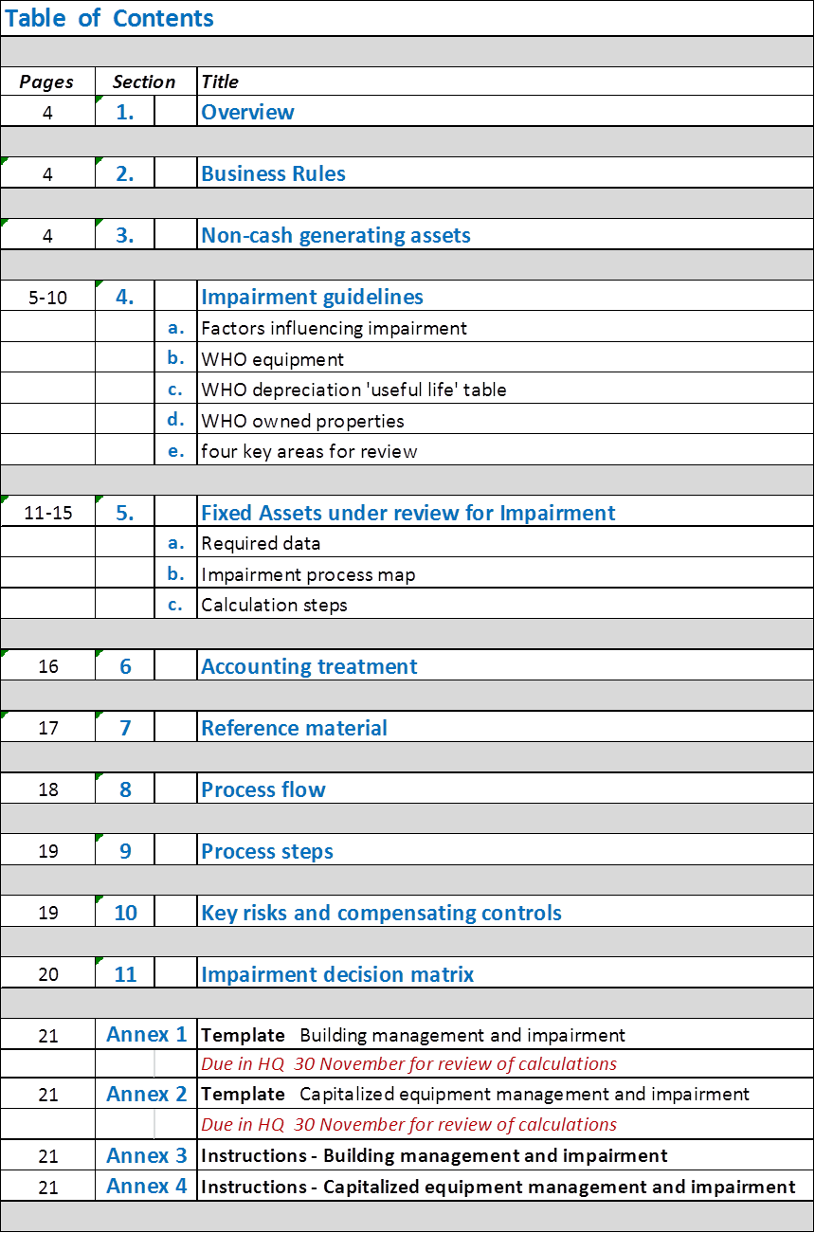

Overview

The purpose of this document is to describe the administrative practice and procedures relating to fixed asset impairment and to facilitate compliance with the WHO Manual and the International Public Sector Accounting Standards (IPSAS 21).

Business Rules

WHO IPSAS policy is to disclose the following in the annual Financial Report (individually, by asset category and in total):
- the amount of impairment losses recognized (or gains from a reversal of an earlier impairment) during the year
- the reasons for the impairment losses (or reversals)
- whether ‘fair value’ is used for impairment testing
- the methodology used in calculating the ‘fair value’

NB: This is a collaborative process done with the close support of HQ/OSS/AMG.

Non-cash generating assets

The fixed assets of WHO are classified under IPSAS as non-cash generating assets because they are held for the primary purpose of delivering WHO services to its member states, rather than to generate cash for a commercial return.

This standard operating procedure applies to capitalized fixed assets not fully depreciated (property and equipment), i.e. assets costing USD 20,000 or more with a Net Book Value (carrying amount) above USD 1,000.

WHO fixed assets below this threshold are fully expensed.
Refer 0SS.SOP.XIII.002 Asset Management

Impairment guidelines

Impairment is a loss in the future economic benefit, or service potential of an asset, above the natural reduction in value as a result of an assets normal use, as defined by the WHO depreciation schedule and the ‘useful life’ ascribed to it.
Refer 0SS.SOP.XIII.002 Asset Management

WHO IPSAS policy is to account for any material reduction in value (greater than 25%) by adjusting the net book value of the asset to recognize the loss of service potential, and reflecting the reduction in the annual Financial Report, stating the reason and methodology used to arrive at the new value.

This could mean that, due to challenging local conditions, a WHO vehicle may be assessed as being beyond repair and therefore have no service potential after only two years of use, whereas under normal circumstances the ‘useful life’ of a vehicle for depreciation purposes is five years.

The aim of the annual review is to determine if significant impairment has occurred during the previous 12 months of use.

  - Factors influencing asset impairment

- cessation or a significant reduction in the demand for the service provided by an asset

- obsolescence

- regulatory changes reducing the ability of WHO to utilize the asset as it was intended

- significant physical damage

- service performance significantly below specification

- decision to stop construction/renovation of a building

  - Impairment review – WHO Equipment

IPSAS 21 requires WHO to review its fixed assets for impairments before each reporting date.

Therefore, during the annual equipment verification each WHO office is to confirm that each item of capital equipment is functioning (and available for service to WHO if required).

When and what needs to be done:
- During the physical verification process check to ensure these assets are not damaged or have any signs of reduced operability.
(The aim being to ensure that the remaining service potential at least matches the remaining WHO depreciation useful life).
e.g. equipment not in use or severely damaged and in limited use

- In addition:
- Note if there are any long-term changes in the use or expected use of any capitalized asset, or class of assets, causing a significant reduction in their service potential
e.g. early retirement of vehicles due to a decision to lease vehicles due to changed operational requirements

- Or if there have been any significant changes to local regulations or technologies that render a capitalized asset or class of assets, obsolete.
e.g. a decision made by a country to increase the price of diesel fuel to the degree that it would significantly reduce the value any WHO diesel vehicle(s) less than fives years old.

This exercise should be approached in a pragmatic manner. IPSAS requires that the impairment should be evident.

An in-depth analysis of every capitalized asset to determine if the useful life precisely matches the NBV is not required.

Capital equipment that is not functioning or expected to be used in future is to have the “In Use” checkbox unticked in the asset workbench for the asset concerned.

This process is to be confirmed in writing on the annual equipment verification memo sent to HQ/AMG at year-end.

How is this to be done: Please refer to OSS.SOP.XIII.002D Fixed Assets (Equipment) Tracking, Verification and Reporting.

  - WHO depreciation ‘useful life’ rule

WHO capital assets are depreciated for accounting and reporting purposes, as follows:

- Buildings (permanent): 60-100 years, depending on the circumstances
- Buildings (temporary): 5-10 years,
- Warehouses: 15 years,
- Vehicles and transport equipment: 7 years
- Computer & communications equipment: 8 years
- Machinery & specialized equipment: 8 years
- Furniture: 15 years

  - Impairment review – WHO owned properties

IPSAS 17 requires WHO to conduct an annual review of owned properties (Land and Buildings) to test for impairment loss (or whether appropriate to reverse a prior period impairment loss).

If significant impairment has occurred, it is to be documented, valued, disclosed and detailed in the Notes to the Accounts.

The annual impairment review seeks to ensure that WHO continues to enjoy the full service potential intended when the property was purchased or constructed.

WHO owned property is disclosed at historical cost less accumulated depreciation (inclusive of capital improvements); therefore a pragmatic approach is to be used when reviewing the properties for impairment.

The impairment analysis and review is conducted annually by the building management team in each relevant Office, verified by the Director, OSS (HQ), DAF (RO), and WR (CO).
Refer

  - Four key areas for review - Buildings

- Building performance over the past 12 months – has it broadly been in accordance with specifications in the design and construction agreement? This test can cover areas such as the performance of the various building components and materials, and the overall efficiency of the building. The more stringent the design specifications, the easier it is to measure impairment. Age must be considered and therefore this test is more applicable to newer structures.

- Has there been a change in the use of the property that has reduced its service potential to WHO over the past 12 months? This could include a situation where due to large reductions in staff a recently constructed building was only 50% occupied. This is a broad test and subjective in its nature, however any real or perceived reduction in service potential, needs to analyzed, documented and valued.

- Has there been a change in regulations during the past 12 months that reduced the ability of WHO to enjoy the intended benefits from the ownership of the land or buildings? This test monitors changes in local or national rules that can result in a significant reduction in the ability of WHO to receive the full benefit of the property, as envisaged at the time of its purchase or construction.

- Has the property been well maintained during the past 12 months to ensure WHO continues to benefit fully from its use. This test seeks to analyze changes in physical condition that impact the ability of WHO to enjoy the full service potential from the ownership of the property.

This exercise should be approached in a pragmatic manner. IPSAS requires that the impairment should be evident.

The results of the building impairment review are to be forwarded to HQ/OSS/AMG by Nov.30 each year.
Refer Annex 1: WHO Owned Property Impairment template

Fixed assets under review for impairment

  - Required data – to be provided to HQ/OSS/AMG only in cases where an impairment has been highlighted for further investigation.

Due to the implications of disclosing an impairment loss (or the reversal of a previous impairment) on each of the major financial statements in the WHO Financial Report, combined with the specific disclosure requirements of IPSAS to detail the reasons behind an impairment, the provision of the below documentation forms a critical step of the internal control process.

When a WHO fixed asset is under review for impairment (or the reversal of a previous impairment), the following documentation is to be provided to enable a complete assessment of the potential loss:

- Asset description
- Major and minor category
- Barcode number (if equipment)
- Date placed in service
- Purchase cost when placed in service
- Carrying amount (Net Book Value – NBV)
- Custodian and unit/department
- Reasons for the impairment
- Estimated USD price obtainable to sell the asset ‘as is’
- Estimated USD selling costs to complete the sale ‘as is’
- Cost of repairs in USD to enable the asset to perform as originally intended
- At least two written estimates of the current fair value, or reason why this cannot be obtained

HQ will then analyse this data to calculate the potential impairment loss and transmit the calculations to the Regional Office for review, approval and certification.

Once approval has been obtained, a copy is to be sent to HQ/AMG to enable the impairment to be reviewed and recorded in the FA module.
refer WHO IPSAS manual section 21 Impairment of non-cash generating assets

  - Impairment process map

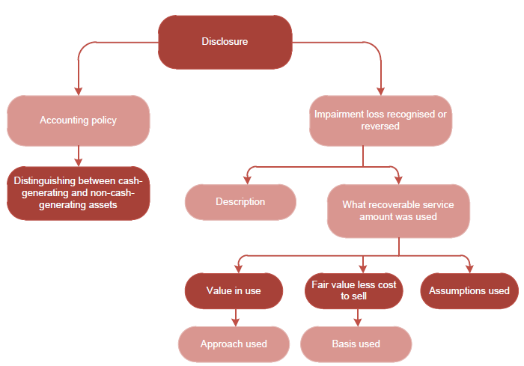

  - Calculation steps – to be done by HQ/OSS/AMG in conjunction with evidence supplied by the office concerned.

The following calculations are to be performed and documented:

- the recoverable service amount of the asset and compare this to the asset’s current NBV (carrying amount)

If the NBV is materially greater (> 25%) than the recoverable service amount, then the asset is liable to impairment

The recoverable service amount (which under IPSAS must exclude any potential insurance reimbursement) is the higher of:

- the fair value (net of selling costs), or
- the asset’s value in use

a. The net fair value represents the amount obtainable from the potential sale of the asset, net of sales costs (advertising, fees for dismantling, handling, legal, tax, cleaning and servicing to enable the asset to be suitable for sale):

- a sales agreement for this asset(s) or identical assets,
- the market value of the asset(s) if an active market exists or,
- the amount obtainable from an arms length transaction between two willing parties, or at worse, a reasonable estimate

b. For WHO assets, the value in use is the present value of an assets remaining service potential, calculated by using either:

- the depreciated replacement cost – changes in use or environment
- the restoration cost – more suitable for damaged assets

The appropriate choice to measure the ‘value in use’ depends on the availability of data, and the nature of the impairment.

Some examples:

- The depreciated replacement cost approach. This is the current cost that will need to be incurred to replace the asset’s service potential, after being depreciated to reflect the asset’s current age/condition.

e.g. WHO purchases a new server at a cost of USD 90,000. The WHO useful life for depreciation is three years.
Therefore the NBV (carrying amount) = USD 30,000 (90,000 less depreciation of 60,000 {90,000/36 x 24}

After two years Microsoft introduces new server technology that results in the new price for a model with similar or improved specifications being available for only USD 60,000.

The estimated net sales value for the current WHO server is reliably estimated at USD 32,000

1. Calculate the value in use:
new server cost = 60,000
less, 2 yrs depreciation of 40,000
(60,000/36 x 24) = 60,000 - 40,000 = 20,000
20,000 (using depreciation replacement cost)

2. Calculate the fair value:
32,000 (estimated net sales value obtainable)

3. Calculate the recoverable service amount:
32,000 (the higher of the ‘value in use’ or the ‘fair value’)

4. Compare to NBV to determine if impairment exists:
NBV of 30,000 < recoverable service amount of 32,000

Therefore no impairment exists

ii. The restoration cost approach. Using this approach the recoverable service amount of the asset is the depreciated replacement cost, less the cost required to repair the damaged asset.

e.g. WHO has a fleet of ten trucks for delivering humanitarian supplies in a large CO, purchased in 2010 for USD 50,000 each.

The trucks were expected to be used for five years after which they would be replaced.
Under WHO depreciation rules the useful life of vehicles is five years.

After 18 months, there was a fire in the neighbouring premises and one of the trucks was severely damaged.

The quote for repair is USD 10,000 and the cost of new truck with the similar specs is USD 52,000

The WHO NBV after 18 months = USD 35,000
(cost USD 50,000 less 18 months of depreciation of USD 15,000 = 50,000 – 15,000)

1. Calculate the value in use:

new truck cost = 52,000
less 18 months depreciation of 15,600 (52,000/60x18)
52,000 – 15,600 = USD 36,400

The deprecation replacement cost is 52,000-15,6000 = 36,400
Restoration cost = deprecation replacement cost less the cost of repairs:
= 36,400 – 10,000
= 26,400

2. Calculate the fair value: 23,000 (best offer obtainable from local truck importer)

3. Calculate the recoverable service amount:
26,400 (the higher of the ‘value in use’ or the ‘fair value’)

4. Compare to NBV to determine if impairment exists:

NBV of 35,000 is 33% > recoverable service amount of 26,400

Therefore an impairment loss of USD 8,600 exists

Accounting treatment (HQ process for all impairments)

If an analysis of an asset shows that the recoverable service amount is less than the NBV (carrying amount), then WHO will need to reduce the NBV to the same level. Providing the NBV is above zero, depreciation will be calculated each month from this reduced amount over the remaining useful life of the asset.
Refer FIN.SOP.XIII.001 Fixed Assets Closure and Depreciation Accounting

Example:
- vehicle cost new $50,000
- useful life for depreciation 5 years
- accumulated deprecation after 4 years = $40,000 ($10,000 p.a. x 4)
- NBV after 4 years = $50,000 – $40,000 = $10,000
- At the end of year 4, due to a non-repairable accident, the recoverable service amount is estimated at only $1,000
- Impairment loss to be recognized = $9,000

Accounting action:
- adjust the vehicle NBV in GSM to $1,000 so as to align with the recoverable service amount
- depreciation will be recalculated over the remaining useful life (1 year)
- impairment loss of $9,000 to be recognized in the annual financial report

Financial effect and disclosure:
- reduction in the value of non-current assets in the Statement of Financial Position
- increase in expenses (impairment expense) in the Statement of Financial Performance
- increase in expenses (impairment expense) in the Statement of Cash Flow
- detailed notes to the accounts documenting the assets affected and the reasons behind the impairment (or impairment reversal)

Reference material

    - WHO eManual
- XIII.3 Premises, Assets and Inventories
- XII.7.1 Year End closure process

    - WHO IPSAS Manual
- section 21 Impairment of non-cash generating assets

    - Related SOPs
- OSS.SOP.XIII.002 Asset Management
- OSS.SOP.XIII.003 Land & Buildings
- FIN.SOP.XIII.001 Fixed Assets Closure and Depreciation Accounting

    - Other
- International Public Sector Accounting Standards (IPSAS), no. 21

PROCESS FLOW

PROCESS STEPS

Step | Control (C) | Type | Process | Role / Responsibility
1 |  | Off-line | Annual physical verification | AMG unit, HQ and RO’s
2 | C | Off-line | Assets reviewed for impairment/revaluation during annual physical | AMG unit, HQ and RO’s
3 | C | Off-line | Request for asset impairment/revaluation | Dir, OSS/HQ
 |  |  |  | DAF, RO’s
4 | C | GSM | Update asset details in GSM

KEY RISKS & COMPENSATING CONTROLS

Risks | Compensating Controls | Process Step
Asset values miss-stated in the WHO Financial Report | Review of all asset during physical verification for impairment | 2
Asset values miss-stated in the WHO Financial Report | Review of impairment requests for their accuracy | 3
Volume of impairments unreasonably high | Regular monitoring of assets to ensure well managed and maintained, risk of impairments minimized and occurrences analysed to ensure avoidable impairments do not reoccur. | 3

IMPAIRMENT DECISION MATRIX

Annex 1: Building Impairment Template
to be completed for each owned property, certified, and forwarded to HQ/AMG by 30 November

English Francais

Annex 2: Instructions – Building impairment annual review

